EXCELLENT WIN TO THE SOUTHERN STORM
Unlike the previous week, the Southern Storm Colts were greeted by bright sunshine, a slight breeze and excellent ground conditions at ANZAC Park when they took on Lindisfarne last Saturday.
With the ‘Cygnet Community Bank Football Club’ Senior and Reserve sides having the bye round, the Storm game was the Club’s only game for the weekend.
The Storm made the most of the ideal conditions kicking six straight goals to the bottom end in the first quarter to take a handy five goal lead into quarter time. The goals were being shared around with six individual goal scorers. Lindisfarne hit back with two early goals in the second quarter before the Storm settled and kicked the next four goals to extend their lead to seven goals at the long break.
With Coaches Matt Brereton and ‘Squid’ Gordon encouraging the boys to move the ball quickly and continue putting pressure on their opponents, the Storm kicked the only three goals of the third quarter to further extend their lead. The last quarter was all the Storm’s as they piled on seven goals to one, with six goals to Joe Direen for the quarter to run out convincing winners by 101 points.
The midfield of Liam O’Neill, Jack Bester and Toby Cowen gave the Storm plenty of drive and benefited from the good ruck work of Jack Brereton. Paddy O’Neill and Campbell Gane were strong in defence all day and continually drove the ball forward.
Big Joe Direen hit the scoreboard with another bag of 9 goals (his third for the season) and he now has 67 goals for the season. Other goal scorers were Jack Bester 3, Jake Dance 3, Toby Cowen 2 and singles to Jack O’Neill, Hallam Blacklow, Elijah Reardon and Jake Munnings.
The win has moved the Storm to third place on the ladder but only two points separates them from Dodges Ferry (4th) and Lindisfarne (5th), who both have winnable games this week while the Storm boys have the bye.
A real dampener on the result was an unfortunate head clash which has left Sean Burgess with a fractured jaw, requiring surgery this week. Sean has been an excellent team player and contributor to the Southern Storm all season and his drive and enthusiasm will be sorely missed. Hoping you have a speedy recovery Sean.
PORT VERSES SORELL THIS WEEKEND
With the Storm having the bye this weekend, the Port Seniors and Reserves travel to Pembroke Park to play Sorell. With only three roster games before the finals, all remaining games are now ‘must wins’ for both sides.
The following week (Aug 13th) Cygnet play Huonville at Kermandie with the Port’s final game at home will be against Hobart on August 20th. The Southern Storm Colts will then play Lindisfarne at Cygnet on August 27th while the Port Senior and Reserve teams have another bye. The first week of the finals will be held on 3rd September.
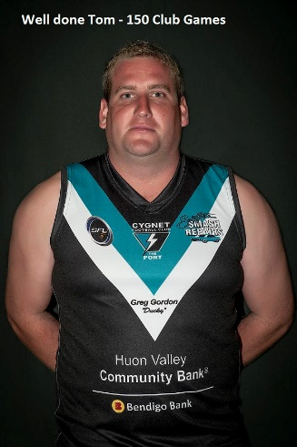
150TH CLUB GAME FOR TOM SLEVIN
Congratulations to Tommy Slevin who this weekend will play his 150th game for the Port. Tom started playing Colts back in 2007 and his playing record includes 15 Senior games, 60 Reserve games and 74 Colt games. Tom is having an excellent season in 2016 playing the full back role. Everyone at the Port wishes Tom well for his milestone game.

Major Sponsor: Cygnet ‘’Top’’ Hotel
Naming Rights Sponsor: The Huon Valley Community Bendigo Bank
Associate Sponsors: Tascon, Duggans Pty Ltd, Southern Smash Repairs, Abel Labels, Cowen’s Drapery, Cygnet Water Cartage, Cygnet Newsagency, Cygnet Building and Joinery, Farah’s IGA Everyday, Elite Painters, B&T Glass, Robert Armstrong MLC, Mal’s Hire & Hardware, Luke Synnott Excavations and Contracting, Aaron Gordon
Weekly Award Donors: Phillip & Loretta Wilcox [Wilcox Electrical], Bill Cribbin’s BP Cygnet, Roys Bits of Old Pizza and R & D Meats
‘’Support the Port in 2016’’

