PORT NEWS
MIXED RESULTS FROM ROAD TRIP TO BRIGHTON
Last Saturday the ‘Cygnet Community Bank Football Club’ headed up the Midland Highway to Pontville to take on the Brighton Robins. The Seniors and Southern Storm Colts came away with hard-won victories whilst the Reserves were beaten by the Robins. The PORT Women’s team, after their first game last week, had a bye last weekend.
Southern Storm Colts
The Southern Storm Colts looked a bit flat early in their contest and after an even first half narrowly led by five points. With Coach Matt Brereton encouraging his charges to move the ball quickly and more directly to the forwards, the third quarter was all the Storm’s as they piled on five goals to nil to open up a handy six goal lead at the final change.
The last quarter was a real physical affair with the Robins kicking two goals to the Storm’s single goal, but the Storm hung on for a well-deserved win by 29 points.
Will Donato was again in fine form across the backline while other good contributors were Jacob Hayers, Peter O’Neill, Jake Dance (5 goals), Jackson Gordon and Scott Blacklow (2 goals). Others to hit the scoreboard were Jacob Hayers, Jackson Gordon, Liam O’Neill and Sean Burgess.
The win moves the Storm into third place on the Colt’s ladder and this week they take on ladder leaders, New Norfolk, in what should be a keenly fought contest.
PORT Reserves
With several players promoted to the Senior side to cover for player losses due to injuries incurred the previous week against Huonville, the PORT Reserves were going to struggle against the Robins on their home turf.
The PORT got off to a very good start kicking four first quarter goals to Brighton’s one to lead by 17 points at quarter time. But that was effectively where the PORT’s run ended with the Robins getting their team game going and kicking five goals to none in the second quarter to take an 11 point lead at half-time. The final two quarters were all Brighton’s as the PORT tired, allowing the Robins to kick six goals to one for a final margin of 44 points.
Better players for the PORT were Chase Connolley, Matty Cane, Brad Sculthorpe, Reece Polley, Adam ‘Rusty’ Direen and Ben Smith. Chris Stockfield was the only multiple goal scorer with two goals with singles to Matty Cane, Tim Bakes and James Booth.
The Club thanks the ‘retirees’ who pulled on the boots to help out the Reserves and also to the Storm players who doubled for a second game and acquitted themselves very well.
PORT Seniors
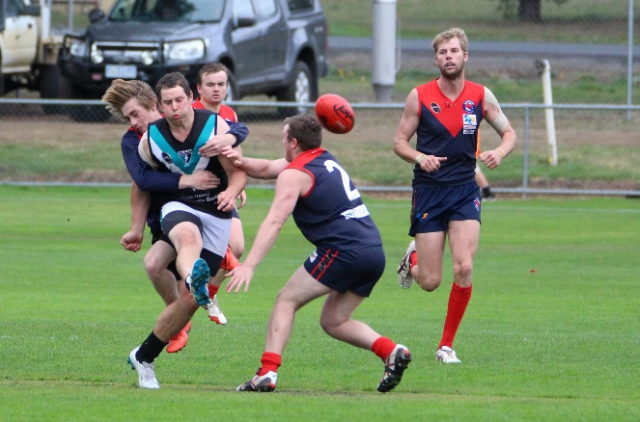
It was virtually a new-look PORT Senior team with seven changes due to injury, including the loss of key players Ben Halton, Brayden Hayes and Grant Clark. In what was a potential danger game for the PORT, their replacements, including first-gamer Matt Turnbull and Tom Slevin, acquitted themselves well in the wet and windy and wet conditions which greeted the start of the game.
First-gamer Matt Turnbull gets his kick away
The first quarter was all Brighton’s as they continually attacked with the strong, swirling wind but their inaccuracy (two goals from eleven scoring shots) kept the PORT in the game, despite the PORT not registering a score for the quarter. The second quarter was a much better effort from the PORT with six goals to nil, including three goals to Will Ford who was relishing his move to the forward line.
The half-time margin was 19 points in the PORT’s favour and with the weather conditions improving it was down to who could handle the slippery conditions the best. The third quarter was a tight even affair with both teams kicking four goals and the game was still in the balance at three quarter time.
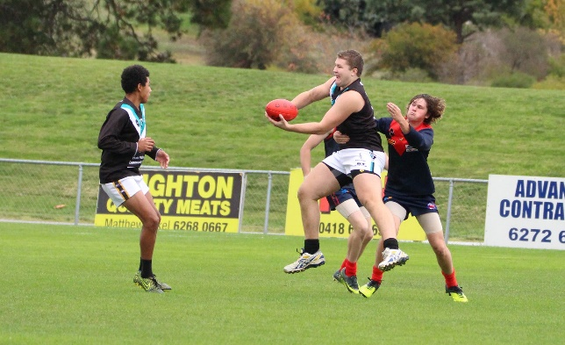
The last quarter went goal for goal with the PORT able to answer all the Robin’s challenges and extend the final margin to 28 points.
Josh Halton handballing to Elijah Reardon
Will Ford finished with numerous possessions and 5 goals, making a strong case to stay up forward for coming games! Sam Dean was excellent in and under the heavy contests while Rhys Jennings stuck to his task and played tight on his opponent all day. Others to play well in an even team performance were Tommy Slevin down back, young Elijah ‘Cyril’ Reardon who finished with four goals, and Andrew Palmer who is starting to regain the form he had before going overseas. Others to hit the scoreboard included Joe Direen (2), Julian Parker, Josh Halton, Rhys Jennings and Mitchell Direen.
The win leaves the PORT in sixth position, narrowly behind fifth-placed Huonville on percentage.
This week’s Games
The PORT Men’s and Storm teams will again be on the road this Saturday, this time to Boyer Oval, to play undefeated ladder leaders, New Norfolk. The PORT Women will play the South East Suns at Shark Park, Dodges Ferry on Sunday 14th May.
The following week (20th May) there are no SFL games due to the NWFL v SFL game but the PORT Women will play Claremont at the Kingborough Twin Ovals on Sunday (21st May).
On 27th May the PORT and Storm men will play Hobart at Kermandie.
“Support The PORT in 2017”

