PORT CLUB NEWS - 14 JUNE 2017
Representative Football
Although there were no SFL games over the Long Weekend due to the Tasmanian Representative game, several of the younger Port and Southern Storm players were selected to represent Tasmania or Southern Tasmania in under-age representative games.
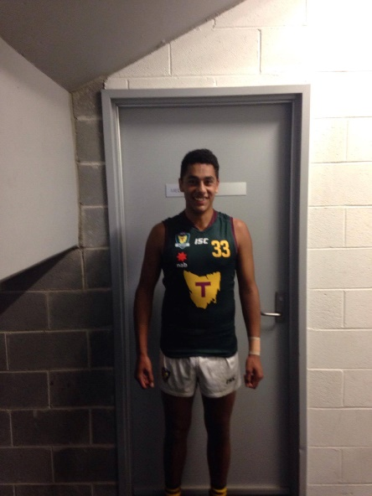
Elijah Reardon travelled to Sydney as a member of the Tasmanian under 17 team who had a comfortable ten goal win over a combined NSW/ACT team. Elijah kicked two goals.
Also, ex-Southern Storm player Bailey Gordon represented the Tassie under 16 team who played the Northern Territory on Monday, also in Sydney. The Tassie boys had a big 88 point win, 127 to 39.
George O'Neill, Josh Coad, Kade Francis and Jordan Lane played in the Southern under 16 team versus the North at North Hobart on Sunday. After leading by eight points at the final break, the Southern boys kicked six goals to one in the final quarter to run out winners by six goals.
Not to be outdone, Ella Brereton Tayla Clifford, Taylah Dillon represented the Southern Girl's under 16's versus the North, also at North Hobart. Unfortunately despite leading at half time, the Southern girls lost by 19 points.
Congratulations to all these players on their selection and what a great effort for a small country club in the Huon Valley to have so many representatives.

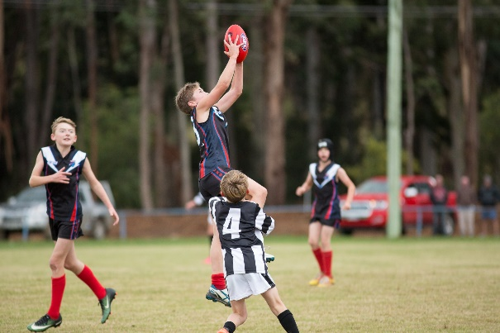
Zac is off to Darwin
Speaking of State representatives, young Southern Storm lad, Zac Curtain has been selected in the Tasmanian under 12 team to play in the National Championships in Darwin in August.
Zac, who lives in Cygnet, is the son of past player, Jonny Curtain and grandson of one of Cygnet's toughest players, Ricky ‘Strop’ Bourke.
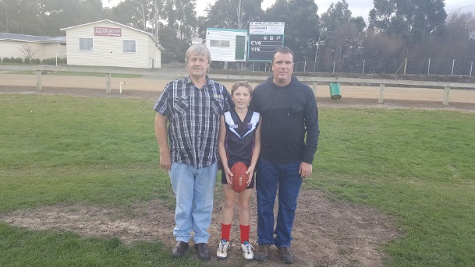
Jonny played over 100 Colts and Reserve games for the Port between 1997 and 2003, whilst Ricky played over 200 Senior games as a ruck-rover and half-bank flanker between 1973 and 1984. He was a member of 4 Cygnet Senior Premiership teams (1974, 76, 79 and 84), and also represented the Huon Football Association on several occasions.
Young Zac is also a talented cricketer and soccer player.
A GoFundMe page ‘Help Zac Go to Darwin’ has been established to help raise funds towards Zac’s travel expenses. The Port’s Naming Rights sponsor, the Huon Valley Bendigo Community Bank, has kindly donated $500 and Kermandie Past Players $250 towards these costs.
Footy returns to Snug Park
This Saturday (17th June) footy returns to Channel's Snug Park, when the PORT and Southern Storm take on Sorell.
Tom Moore & Son, a great supporter of the Channel Football Club for many years have now come on board as one of the Port’s Corporate Sponsors, and will be the Game Day Sponsor for the Sorell game.
This will be a great opportunity for the local Channel supporters to watch a number of their former Channel players playing for the Port. These players are highly respected around the Cygnet FC and have quickly become an integral part of the Port teams in season 2017.
It should be a great day with the Port Women playing the South East Suns between the Reserve and Senior games.
So get along to Snug Park on Saturday for what promises to be four great games of footy.

Port Comedy Night (24th June)
Get your tickets for the Port’s Comedy Night, which will be held following the next home game against Dodges Ferry.
The live ‘Legends of Review’, proudly sponsored by Southern Smash Repairs, includes several local comedians including the very funny John X in what should be a fantastic night of fun and side-splitting laughter.
See the Club’s Facebook page for all the details and where to get your tickets.

Past Players and Official Day
A date for your diary. This year’s Cygnet FC Past Players and Officials Day will be held on Saturday 22nd July, coinciding with the Club’s home game against Brighton. More details will be provided over the coming weeks.

