PORT CLUB NOTES – 5 August 2017
A BLEAK WEEKEND FOR THE PORT
Perfect playing conditions greeted the Cygnet ‘Community Bank’ Football Club when they journeyed to the TCA Ground last Saturday to take on the Hobart Tigers. On Sunday the Port Women also had an away game against the top team, South East Suns at Sorell.
Unfortunately, it was a bleak weekend on the results’ front, with all four Port teams going down to their Hobart and Suns opponents.
Southern Storm Colts
The Southern Storm were hoping to put in a competitive performance against the undefeated Tiger team. However, it was soon clear why Hobart had met all challengers this season, with their physically stronger bodies and quick ball movement creating plenty of scoring opportunities. The Storm were ‘monstered’ in the close-in contests and weren’t able to get the clear break away. A five goals to nil first quarter had the Tigers well up at quarter time. The Storm lifted their work rate in the second quarter, matching it with their opponents but despite this the margin had crept out to 45 points at the long break.

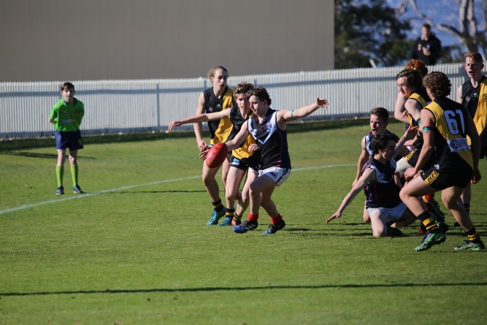
The third quarter was more of the same with Hobart kicking five goals to the Storm’s two goals and the margin was out to over ten goals. The Storm never gave up but were kept scoreless in the final quarter by the strong Hobart defence, who continued their unbeaten run to the tune of 78 points.

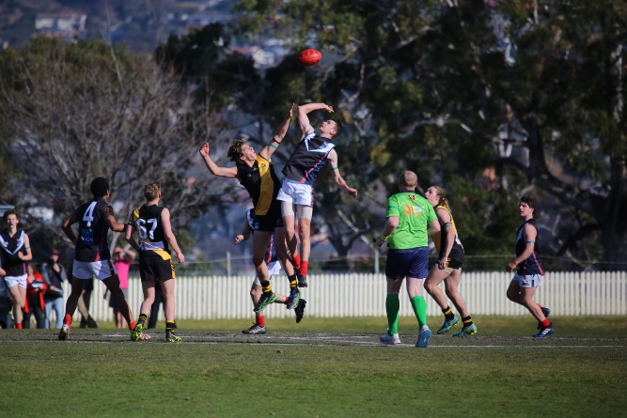
Better players for the Storm were Will Polley, who continues to impress, Jack Brereton who was more than competitive in the ruck and with his marking around the ground, along with Jake Munnings, Kyle Russell, Will Donato and Jake Dance. The Storm’s three goal scorers were Jake Dance, Marcus Coulson and Jacob Hayers.
Sean Burgess gets his kick away

Jack Brereton wins the tap

PORT Reserves
The first quarter was an even affair with both sides using the ball well but the Tigers held a narrow seven point lead at the break. The Port made the most of the slight breeze in the second quarter kicking three goals to the Tiger’s one goal to take a six point lead at half-time.
The second half started much the same as the first as the two teams swapped goal for goal and Hobart were able to regain the lead by five points, and an exciting final quarter was expected. Despite having much of the play in the final term, the Port just couldn’t hit the ‘big sticks’, kicking five straight behinds to reduce the margin to one point. But in a rare foray forward late in the quarter, Hobart were able to score the only goal for the term to run out victors by seven points.
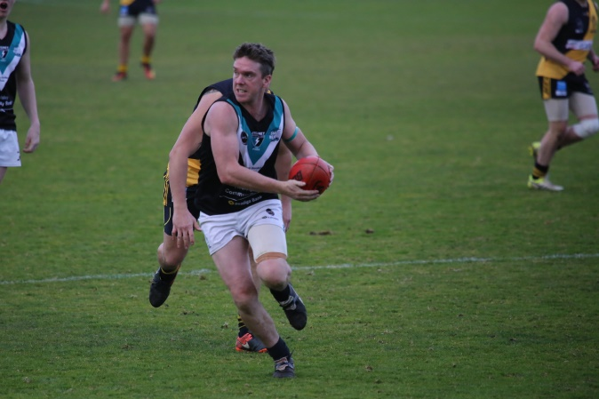
In a much improved and competitive team performance, James Booth, Sammy Pritchard, Brad Sculthorpe, Matt Coulson and Luke Smith were good contributors. Dwain Warn was the chief scorer with 3 goals, with single goals to Daniel Webster, Chris Stockfeld and Jack Brereton. The Club would like to acknowledge the efforts of the Storm players, Hallam, Bryce, Sean, Kyle, Jack and Jacob who pulled on the Port jumper to help out the Ressies field a team.
James Booth breaks away

PORT Seniors
After a good showing the previous week against ladder-leaders, New Norfolk, the Port Seniors were keen to continue their recent good form against the seventh-placed Tigers. Josh Halton returned from illness replacing brother, Ben who had suffered a wrist injury the previous week. Also absent was reliable backman, Tom Slevin.
The Port, kicking with the aid of a slight breeze to the Aquatic Centre end, were moving the ball quickly and had the three of the first four goals on the board, before Hobart steadied and kicked several goals late in the quarter to take a two point lead at the first break. Injuries to Rhys Synnott (knee) and Corey Polley (hamstring) meant that the Port’s bench was down to two early in the game.
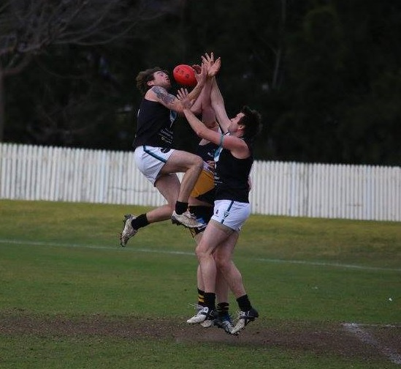
Despite having much of the play in the second quarter, the Port could not covert through the ‘big sticks’, only managing four behinds for the quarter. Fortunately, Hobart were having similar accuracy problems at the other end, kicking two goals five behinds, but had extended their lead at half-time to 15 points.
The Port gave a much better showing in the third term, with Gerard Brereton winning the taps and Sam Dean and Rhys Jennings continually driving the ball forward, giving forwards Joe Direen, Will Ford and Josh Halton several scoring opportunities. The Port’s four goals reduced the margin to two points, but lost Will Ford midway through the quarter after suffering an accidental head knock and he did not play any further part in the game.
Will Ford takes a mark with the flight of the ball
Hobart scored the first goal of the final quarter after a minute or so play, but the Port were still battling hard and again couldn’t manage a goal to the top end. From about the ten minute mark of the quarter the flood gates really opened with Hobart banging on seven quick goals to run out comfortable winners over a very disappointed Port outfit by 51 points.
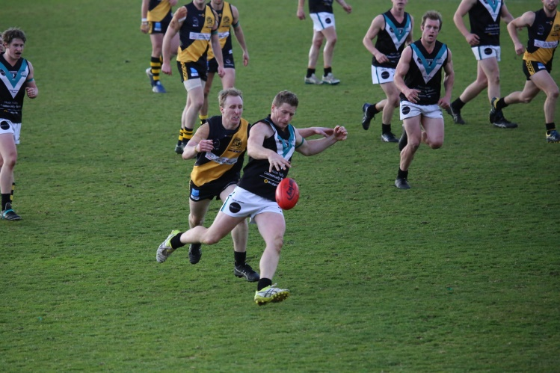
Coach Ben Cato led from the front as he has done all season, battling hard all day and Sam Dean was as tenacious as ever winning numerous contested possessions. Will Ford, kicked two early goals before being moved to defence to help stem the tide and was then back up forward kicking his third goal before his injury. Several of his marks with the flight of the ball into oncoming packs showed tremendous courage. Joe Direen took several marks and kicked two goals in the third quarter, Rhys Jennings showed what a real trooper he is by playing most of the second half with a shoulder injury and Gerard Brereton battled manfully in the ruck winning most of the rucking contests.
Coach Ben Cato gets one of his many kicks
Other single goal scorers were Josh Halton, Ollie Burke, Rhys Jennings and Sam Dean.
The Port and Storm Men’s teams have the Bye this Saturday and the chance to rest up and overcome injuries before their final roster game of the season against Sorell at Pembroke Park on Saturday week (19th August).
Port Women
Port Women travelled to Pembroke Park on Sunday to play ladder leaders, the South East Suns. Just a day or two prior, due to injury and absences it seemed unlikely that the Port would make the trip to Sorell at all.
From the first bounce, the Suns had clear control of the game but were still held to a respectable tally by the Port each quarter. Storm Youth players, Ella Brereton and Casey Chapman stepped up for the Port Women directly after running their Youth game out and both played a fantastic game, no doubt to be seen in the Port Women’s colours in the near future. Port first gamer, Telitha Bird showed consistency and skill over the four quarters and pocket rocket Ash Munnings played her best game of the season. Chantel Clark was again a fine contributor for the Port over the four quarters.
With no rotations on the bench by the end of the game, and feeling the effects of a physical contest, the Port played it out to the final siren, bruised yet dignified. April Pottinger was imposing in the ruck throughout the match and had a great game. In the end, the Suns ran out comfortable 77 point winners.
With just 5 days to regroup and refocus, the Port Women travel to Abbotsfield Park this Friday night for a twilight game against the Claremont Magpies, with the first bounce at 6.30pm. As the only Port game for the weekend, Port supporters are encouraged to get along and support their Women’s team.

GO THE PORT!!!!!

