PORT CLUB NOTES – 2 September 2017
PORT SENIORS BOW OUT BUT STORM COLTS STILL ALIVE
Last Saturday the Port journeyed to Claremont for its final clashes with Claremont (Seniors) and Hobart (Storm Colts). Although conditions were fine, the wind picked up during the day, making accurate scoring difficult.
The Senior loss brings down the curtain on their 2017 season, while the Storm Colts live to fight on in their Preliminary Final clash against New Norfolk this Saturday at North Hobart Oval, starting at 9.15am.
Southern Storm Colts
The Southern Storm lads welcomed back ruckman Jack Brereton from injury for their Second Semi-Final game against the undefeated top team, Hobart Tigers. Hobart had the better of the first quarter scoring three goals to the Storm’s one to lead by two goals at the first break. The second quarter was more productive for the Storm as they started to spread the game and their pace was worrying the bigger-bodied Tigers. The Storm managed four goals to Hobart’s three for the quarter and the margin was only eight points at half-time.
Hobart kicked a couple of goals early in the third quarter to extend their lead, but the tricky breeze was making scoring accuracy difficult for both teams. A couple of late Storm goals and the margin was down to 11 points and it was still anyone’s game with a quarter to play.
The final quarter saw Hobart congest the game through the middle corridor and with their big key forwards marking strongly and converting, their lead gradually extended out to a final margin of 24 points. While not able to secure the victory, the Storm were not disgraced and their performance showed that they can be very competitive and challenge the top teams.
Kyle Russell was again strong in and under the contests, tackling hard and winning many possessions, Campbell Gane and Will Donato defended gamely all day, while George O’Neill (2 goals) and Will Polley continued their excellent seasons and Jack Brereton rucked strongly. Jake Dance was again amongst the goals with two, while Blake Mills, Connor Soward, Sean Burgess and James Zeitzen each scored one goal.
This Saturday’s Preliminary Final will be the Storm’s fifth match-up against New Norfolk this season, with honours currently shared in their four previous contests. A win on the close confines of North Hobart will see the Southern Storm into their first Colt’s Grand Final since reforming under Coach, Matt Brereton last season, which will be an excellent result for a very young team.
Port Seniors
The Port were without the services of injured ruckman, Gerard Brereton and an ill Aaron Dance, but welcomed back Brayden Hayes and Mitch Direen from injury for their First Semi-Final against the Claremont Magpies.
The Port got off to a good start kicking with the swirling breeze to the Clubroom end of Abbotsfield Park and took the lead with early goals to Brayden Hayes and Will Ford. Claremont countered with two of their own before a third Port goal put them in front by 3 points at quarter time. The Magpies got their running game going in the second quarter kicking four goals while restricting the Port to two behinds only, to lead by 24 points at the long break and control the game on their terms.
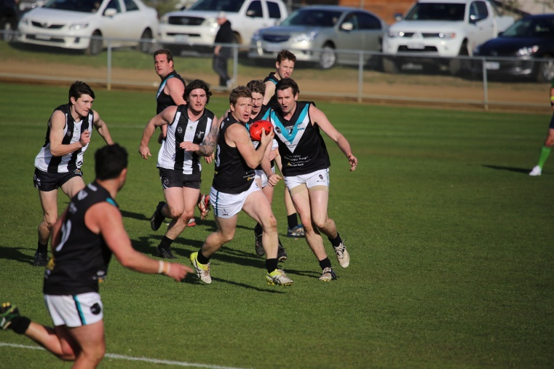
After a ‘bake’ from Coach, Ben Cato, the Port boys came out firing and early goals to Paddy O’Neill and Will Ford had the Port back in the game. A leg injury to Joe Direen caused the Port to shuffle their backline with Kane Nielsen and Cam Wilcox sharing the ruck duties for the remainder of the game. Claremont were able to get a real run on, kicking several quick goals and in the blink of an eye the margin was out to almost eight goals!
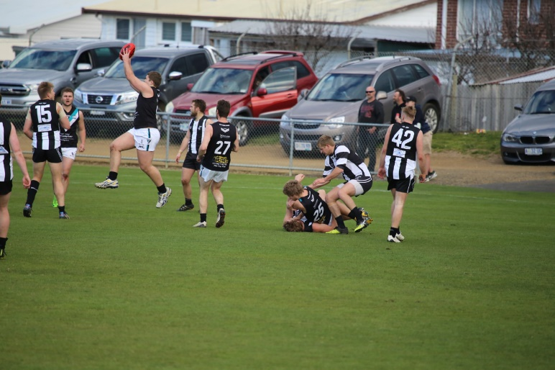
The challenge for the Port was to not let the game ‘blow out’ and to their credit they battled the game right out until the end. With Josh Halton kicking three goals for the quarter the Port were able to outscore their opponents, but it was too late as Claremont ran out comfortable winners by 37 points.
Andrew Palmer worked hard in the midfield all day, Nathan Duggan and Tom Slevin were very competitive down back, Josh Halton (5 goals) and Will Ford (2 goals) were key targets and Joe Direen was competitive in the ruck until injured.
Matt Cane, Brayden Hayes and Paddy O’Neill were the Port’s other goal scorers.
The Club is extremely proud of the team’s efforts and achievement over the season, and its fourth-placed finish is probably indicative given the tough run of injuries experienced through the season.

GO THE STORM!!!!

