PORT WOMEN GRAB FIRST WIN
It was a big day of women’s football at Lauderdale Oval last Sunday as the SFLW held another Gala Day with four back-to-back games.
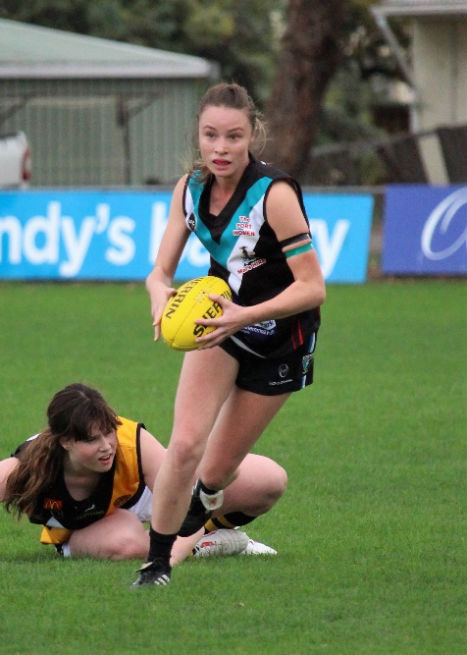
In the second game of the day, the Port Women took on the Hobart Tigers and right from the first bounce the Port showed that they were there to win. Emily Direen got the team off to a great start scoring the first goal of the game. It was great tussle with both teams going hard at the ball and good defence from Hobart forced a few rushed kicks but Emily scored another major and the Port went into quarter time leading 13 to 0.
The second quarter saw much of the same good, hard efforts by the Port. Jaimie Noye stepped into the midfield for a bit of a change and showed everyone that she is a brilliant player who can play anywhere and she will always find plenty of the ball. The backline held strong while the midfield worked the ball down to the forward line on many occasions. Holly Upston scored her first ever goal following it up with a second soon after. The Port extended their lead and went into the long break up 27-0.
Sammy Kluga breaks away from her opponent
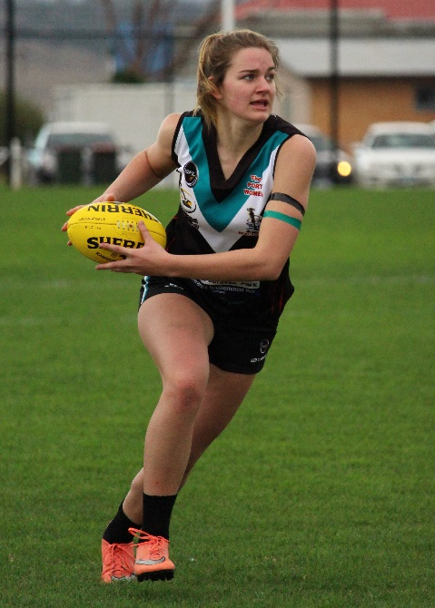
In the third quarter Mattia Duggan show us her forward skills, booting two goals and Holly added to her total by kicking another. The Tigers put in a great third quarter to get the ball down to their forward line but the Port’s tight defence restricted them to a minor score only.
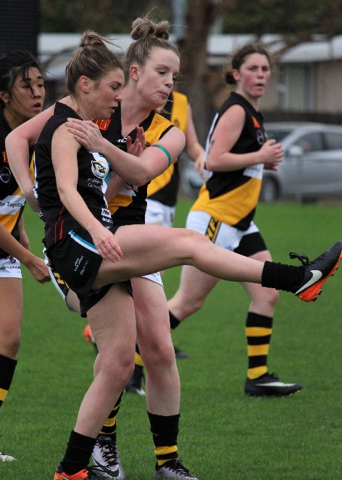
Heading into the last quarter the Port lead 48-1, but the Tigers showing fight to the end, came out strong and scored their first goal for the afternoon. The Port girls kept the pressure up and scored another 3 goals, with Hayley Flakemore kicking her first ever goal and Mattia Duggan adding two more to her total.

Tia Duggan in action

In the end it was a very solid performance by all 22 Port which lead to a well-deserved 71-7 win to The Port.
Better players in a very good team effort were Mattia Duggan (4 goals), Holly Upston (3 goals), Michelle Cowen, Annaliese Dance, Jaimie Noye and Emily Direen (2 goals). Single goal scorers were Hayley Flakemore and Sherilyn Atkins-Collins.
This weekend the Port Women have the bye. Their next game will be against the Lindisfarne Blues at Snug Park (Channel) on Saturday 19th May at 10.30am.
Hayley Flakemore gets her kick away

Men’s games this Saturday
After their bye last round, the Port men’s teams will play home games at Cygnet this Saturday, with the Southern Storm Colts playing Claremont followed by the Reserves and Seniors matching up against Brighton.
Legends of Revue
The Club’s first social function of the year will be held following Saturday’s games, with the very funny ‘Legends of Revue’ returning with their new collection of legendary comedy sketches. Get along for what promises to be a very funny night. Tickets are $20 and are available from the Club, Cygnet Newsagency or via direct deposit. Check out the Club’s Facebook page for further details.

Support the Port in 2018

