Port Notes

The Cygnet Football Club took the long road trip to Boyer Oval last Saturday and returned home empty handed in all three matches, although both the southern Storm & Senior matches were close, and could have gone either way. Today it gets no easier with the Port travelling to Abbottsfield Park to tackle the Claremont Magpies. The Port teams will back in their young legs and run to try to come home with three victories. Make sure you stay for the Port’s women’s match that commences straight after the Senior match at 4.30pm and show them your support as they chase their third win of the season!

Colts
The Southern Storm team were up against the up against an undefeated New Norfolk side this week.
The Storm boys jumped out of the blocks with a three goal to nil first quarter. The midfield was having a great game, delivering lots of ball to the forward line with Jake Munnings taking some lovely marks. The second quarter and third quarters were tight affairs with the Eagles clawing themselves back into the game. At the end of third Storm was still leading by 11 points. The Storm backline was again leading the way with some positive defence and really taking the game on.
All the players were throwing themselves into the contest with no easy ball to be had all over the ground. Unfortunately in the last saw the Storm boys overrun by the home side, who put on 5 goals to 1 in the last quarter to take a win by 15 points.
All the Storm boys should be very proud of their last two games against the two top sides. The team has a few players out and look forward to their return later in the season.

New Norfolk 10.10.70 def Southern Strom 8.7.55
Goal Kickers: J. Munnings 3, M. Bastick 2, C. Walter, N. Clifford, C. Soward
Best Players: J. Burnett, B. Dowling, J. Coad, C. Slater, J. Munnings, L. Slater

Reserves:

Saturday’s Reserve side was well down on numbers for the trip the Boyer Oval. Only 16 players could be gathered prior to the start and the game owed a great deal to six Colts players who doubled up in order to field a side. Scott Blacklow, Josh Coad, Jacob Burnett, Dylan Gane, Connor Soward and Blake Sculthorpe did much more than make up the numbers.
The lack of players was compounded even further by the loss of James McQueen to leg injuries in the warm up reducing the bench to three players before the match even commenced.
Brad Sculthorpe was a rock in defence, consistently spoiling and repelling advances from New Norfolk. Sculthorpe led the defensive unit, working well with nephew Blake Sculthorpe, Jacob Burnett and Chris Stockfield
Shane Clark provided options both up forward and through the midfield. Overhead marking was a highlight of the former coach’s game.
Team captain, Darcy Millhouse gave another tireless performance in the ruck. Although undersized, Millhouse’s work-rate and pressure efforts around the ground was of great benefit to his side.
Young Matthew Coulson made an important contribution with his aggressive attack on the ball and opposition. And Josh Coad was an effective player with his long kicking and ability to read the play.
The final margin was 75 points to New Norfolk which a disappointing result for the club but not a negative reflection on the 22 players who presented themselves for the match.

New Norfolk 15.5.95 def Cygnet 2.8.20

CYGNET
Goal Kickers: M. Coulson, B. Sculthorpe
Best Players: S. Clark, B. Sculthorpe, D. Millhouse, J. Coad, M. Coulson, J. Burnett

Seniors:

It was a chilly day at New Norfolk and an important game for the Cygnet seniors. The Port welcomed in Liam O’Neill for his first game for the season after some great form in the reserves.
New Norfolk came out of the blocks firing scoring 5 goals in the first quarter whilst the Port could only manage the 3. Giving the Eagles a 2 goal lead at quarter time.
During this quarter the backline of the Port faced some serious pressure with the Eagles dominating the inside 50’s. Nathan Duggan and Jackson Gordon stood tall – creating many opportunities on the rebound.
After a quiet start to the quarter the midfield of the Port began to have an influence – in particular; Palmer, Cowen and Cato.
The second quarter saw the Port fight back scoring 4 goals to the Eagles 1 giving the Port a goal lead at the half time break. In a complete role reversal, the Port dominated the inside 50’s in the second quarter as Ben Halton began to have a big influence on the game.
Unfortunately half way through the second quarter The Port lost the dangerous Ollie Burke for the remainder of the game. He was proving to be a handful having scored 3 early goals and was a big loss going into the second half.
The third quarter went the way of the Eagles as they scored 5 goals compared to 4 from the Port. This levelled the game up and built for a thrilling final quarter.
The key statistics were very even within this quarter with both teams winning their share of the centre clearances and inside 50s.
The final quarter saw The Port come out running with the first 4 inside 50 entries. Unfortunately for The Port, inaccuracies in front of goal would be telling at the final siren. In the extreme pressure of the final quarter the Eagles seem to settle a little better and take out an important victory over Cygnet.
Jason Shaw had his best game for the Port taking some strong marks and clean disposal around the ground.
New Norfolk 14.9.93 def Cygnet 12.10.93
Goal Kickers: O. Burke 3, B. Halton 3, B. Cato 2, J. Gordon, J. Shaw, L. O'Neill, P. Verrell
Best Players: B. Halton, N. Duggan, J. Gordon, Paddy O'Neill, G. O'Neill, J. Shaw

THE PORT WOMENS
Gala day at Cygnet Oval saw The Port hosting 4 games with Port being first off against New Norfolk at 10.30am, on a very cool damp morning with the sun trying to come out. The port welcomed back Keren Scotney after being away with injury and passing a fitness test before the game to run out on home turf to play her 100th game.
Michelle Cowen got the tap away which saw the ball go straight to our forwards with Sammy kluge kicking the first major within minutes of the start, another one followed not long after from Tara slater after being awarded a 50m penalty. Sammy kicked another along with Anna Stanway, with Port having a 34 point lead at quarter time.
The girls continued into the second, working well together kicking another 2.4 with Serena Hubert and Telisha Roland scoring leaving us at halftime with a 50 point lead. Renee decided to change things up a bit and put Scotney up forward from her usual position as fullback. Anna Stanway kicked 1 and Scotty kicked 2, following up with another 2 in the final quarter along with Emily Direen. The Port coming away with a win 97 to 1.
After the game the song was proudly sang, Scotty celebrating her 100th women’s game came out a bit wet from the circle. After Renee presented Scotty with a trophy for her wonderful achievement as being only the 3rd Tasmanian female to reach this milestone.
All the women then helped out with scoreboards, gates, canteen, bar, cleaning up and other duties involved in running the day. Well done to everyone on a great team effort for the day.
Next weeks game is at Abbotsfield Park on Saturday 2nd June at 4.30pm after the seniors game.
The Port 14.13.97 defeated New Norfolk 0.1.1

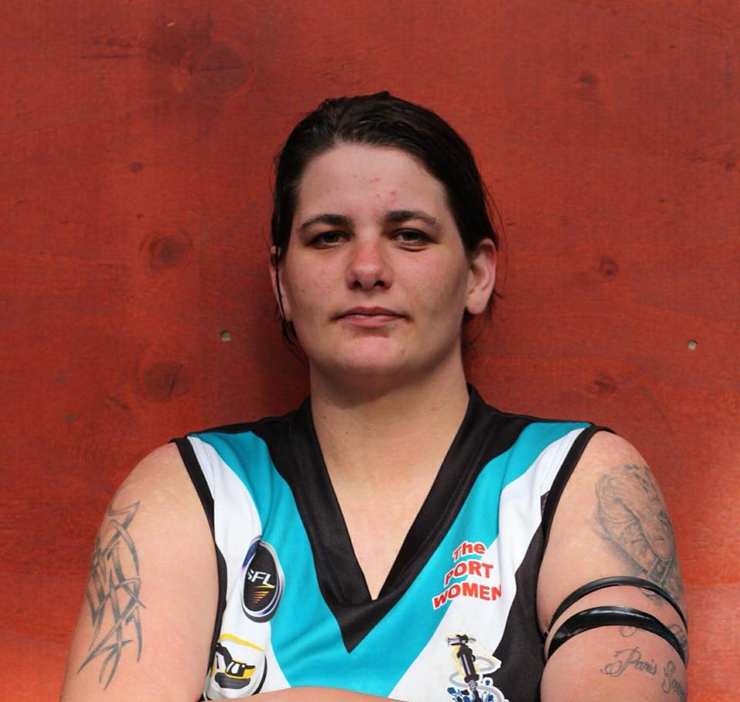

Goal Kickers: K. Scotney 4, S. Kluga 2, E. Direen 2, A. Bellette-Stanway 2, M. Duggan, S. Hubert, T. Roland, T. Slater
Best Players: K. Scotney, H. Flakemore, A. Bellette-Stanway, H. Upston, S. Kluga, J. Noye
Upcoming Social Events
Please keep the following dates free:
Sat. 16th June – Hypnolicious - a great night with comedy hypnotist Matt Hale (Cost $30)
Sat. 30th June – The First to Bust/Get Your Game On! (more details to come)
Sat. 11th August – Past Players Reunion Dinner (details on Guest Speaker to be announced shortly)
Thank you to our Wonderful & loyal Sponsors
Cygnet Hotel “the Top” – Major Sponsor
Community Bank – Naming Rights Sponsor
Cygnet Hotel (The Top)
Huon Valley Community Bank
Southern Smash Repairs, Abel Labels, Duggans, Cygnet Building & Joinery,The Huon News,B&T Glass, Cygnet Water Cartage, Elite Painters, Luke Synnott Excavations, Oakford Plumbing, Commercial Hotel (The Bottom), Festival IGA Everyday, Cygnet Newsagency
Tom Moore & Son, EIS Property, Phillips Civil Contracting, Mal’s Hire, Southport Hotel & Caravan Park, Scott Thiessen, Powermilk
Award Donors
Cribbins BP, The Top Pub, Wilcox Electrical, Roy’s Bitz of Old Pizza, Brereton Electrical Colts, Southern Hope Fishing R & D Meats
‘Support the Port in 2018’

‘Support the Port in 2018’

