**Port ‘’Roll’’ Undefeated Magpies**

A chilly day at Claremont confronted all three teams at Abbotsfield Park last Saturday as the Southern Storm and Port teams looked forward to three hotly contested games after a disappointing road trip to New Norfolk the week before. The end result was two victories in particular a great win by the Storm boy’s and a fantastic win by the senior team over the previously undefeated Claremont side. Both the Reserves and ladies team put in spirited displays.

**Southern Storm**

The morning was very cold and the ground quite wet and dewy, with all players finding ball control difficult. Southern Storm had most of the play but couldn't find a target up forward.

The second quarter continued in the same manner, although Storm took a 4 goal lead into halftime. The second half saw the Storm players starting to move the ball more freely and confidently as the ground dried out.

Storm welcomed back Will Polley after an absence with injury and he was winning most of the ruck contests, providing our midfield with first use of the ball. Noah Clifford was dominating in the centre ably supported by Brayden Dowling playing out of his usual position.

The third and final quarters saw Southern Storm run away with the game, kicking 8 goals to This was a result of team pressure keeping the ball consistently in our forward half, consequently providing lots of opportunity to our forwards. The Storm team welcomed Kade Francis back for this first game of the season and also wished to thank the Kingborough Tigers Football Club for allowing Austin Heald to come and play with us this week.

Southern Storm moved into 2 on the ladder and have a bye this week, we then have a home game at Cygnet against Sorell.

Southern Storm 13.15.93 def 2.4.16

Goal Kickers: C. Soward 4, B. Dowling 2, N. Clifford 2, L. Slater, L. Ashlin, J. Munnings, A. Heald, M. Innes  
Best Players: N. Clifford, B. Dowling, C. Soward, R. Scotland, B. Sculthorpe, C. Slater

**Reserves**

The Reserves were again short on numbers but took heart that some Kingborough boy’s plus a few Colt’s stepped into the breach to assist on the day. The Claremont team are renowned for having a strong reserves team, and a five goal to nil first term had the makings of a long day at the office for the Port lads.

The boy’s fought hard in the second term throwing themselves at the football and applying pressure to the fast Claremont team as best they could, but another 6 goals to the Ports 1 had the game over at half-time. Jack Bester and Jack Brett and Sean Burgess tried hard to stem the flow but the port needed to lift in the second half.

Coaches Burke and Whitehouse asked the boys to win the second half and contain the score-board but the Magpies were relentless and kept their foot on the accelerator. The Port really showed some spirit and grit by kicking 4 last quarter goals to outscore the tiring Claremont team, and full credit as the boy’s tried hard all day against the odds and never threw in the towel. Our thanks to those who assisted to make a team. It’s been a tough season and you can only admire these boys who keep fronting up. Better players included Jack Bester, Jack Bester, Sean Burgess, Matty Coulson, Brandon Lane (3 goals) and Captain Dallas Millhouse. Keep your chins up boys, another win is not far away and the Club is right behind you all!

**Seniors**

In what can be described as an 8-point game, the Port started despised outsiders naturally after losing to the Eagles and facing a second long road-trip in two weeks. However, behind closed doors coaches Cato and Palmer were plotting a game plan and gave some players some key shut-down roles that had to be delivered. The message was simple – apply immense pressure to the ball carriers and upon turn-over, back in the Port’s fast young legs and get the ball into star forward Ben Halton.

The Port were a little slow out of the blocks again in the first term with Claremont dominating the centre clearances, the inside 50’s and the scoreboard early. The backline of the Port were under some intense pressure as the free flowing running game of the Pies midfield got off to a great start with the ball entering the forward line quickly and on many occasions. As usual the back six stood tall, with Gane, Ford, Direen, Gordon, Cato and Duggan repelling many attacks. It wasn’t long before the midfield of the Port got going and once this happened they were able to counter attack. Goals in the first quarter went to Ben Halton and Elijah Reardon.

At the first break the Port found themselves three goals down. At quarter time Coach Cato demanded more from his midfielders as the Port needed to tighten up on the very experienced midfield of the Pies. He commended young gun Jack Brereton in the ruck who was holding his own all over the ground against a very experienced foe. While the Port showed the right intent, Cato expressed the need to be quicker with our options and to be a little smarter in front of goal. Cato paid mention to old timer Mitch Direen who continues to provide plenty of run out of the backline.

The second quarter saw the Pies once again dominate the centre clearances and the inside 50’s, but the immense pressure from the Port’s midfield and defenders meant that the Port were able to make the most of the rebound football. This resulted in plenty of opportunities for the Port’s forwards who remained composed in front of goal. The Port won the second quarter by four goals to the Pies two but at the main break the Port still found themselves one goal behind. Goals in the second quarter went to Halton, Peter O’Neill, Cowen and Liam O’Neill.

While the inside 50’s in the third quarter were even, the Port were a little more composed in front of goal and were able to outscore the Pies three goals to two. It was in this quarter the Port were able to take command of the centre clearances as Palmer, Cowen and Cato continued to provide plenty of run. A dominant display was the turning point in the game as Ben Halton kicked all of the Port’s three goals. A very nasty broken nose to Pat Verrell just before three quarter time would leave the Port short of rotations in the final quarter. Pat was to be sorely missed as he had once again sacrificed his own game to keep one of the best players in the competition from having a significant impact on the game. At the end of the third quarter the game had evened up with the Pies only four points ahead.

While the Pies again won their share of the centre clearances, the Port dominated around the ground in the final quarter. The pressure provided by the Port’s players all over the ground proved to be the difference at the end of the day. The fast finishing and hard running Port amassed a further six goals in the last quarter compared to one from Claremont.

Once again the imposing combination of Halton and Reardon up forward created many problems for the opposing back-men. Goals in the last quarter went to Halton (2), Reardon (2), Palmer, and young rising star James Zeitzen.

In a match where the Port’s leaders lead from the front, every member of the team played their part and as a team they were able to play some of the footy they have been promising. A great win, well done fella’s!! Better players include Andrew Palmer who was easily best on ground and dominated while Ben Halton’s game was brilliant with 7 majors. Jackson Gordon has become an integral senior player as has Campbell Gane, while veterans Rhys Jennings and Mitch Direen keep on keeping on; truly committed Cygnet servants and admired leaders. Young gun Elijah Reardon provided great support to Halton with 3 majors. A great team victory – well done boys!

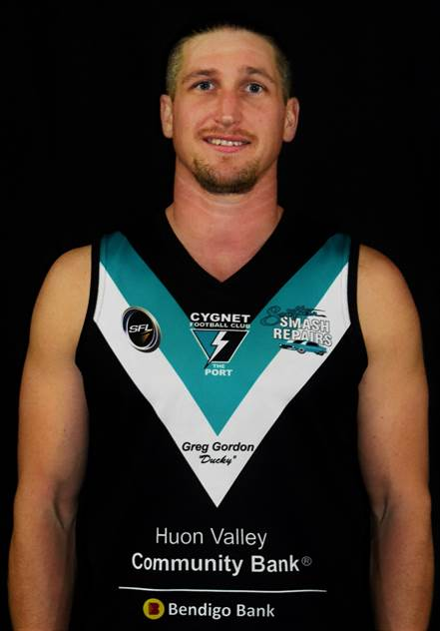

**Andrew Palmer (best on ground)**

**Port Ladies**

Round 10 saw us face Claremont for the second time this season, and after a close contested game in round 1 it shaped up to be another tough contest.   
The first quarter was a battle with plenty of action and both teams were hard at the ball. Claremont scored the first goal of the quarter and The Port struggled to get on the board. But managed a couple of behinds, Claremont played hard and kicked another major. Leading 13-2 into the second The Port were now fired up and came out much harder, and managed to get their first goal on the board through Hayley Flakemore. The backline held strong with Keren Scotney leading the way, going into the main break 21-8.

The Port came out in the 3rd quarter and held the Pies scoreless, with a huge effort in the middle with Mattia duggan, Serena Hubert, Holly Upston, Sheri Atkins-collins, Jessie Burnett, Sammy Kluga and Anna Stanway all getting plenty of the ball, getting up into the forward line for us to score 2 goals through forward pocket rocket Emily Direen. The first being a set shot from a beautiful mark in the pocket, the second a great little "pick up the crumbs" goal.

Heading into the last quarter The Port held a 2 point lead bit both teams wanted to win and both teams came out fighting, again it was a tightly contested hard hitting game with not a lot of free flowing action. But The Port girls kept fighting, Claremont got a free kick and capitalised and the momentum swung and Claremont scored again.

The game wasn't over just yet and The Port managed a great passage up the middle with returning utility player Chantelle Clark taking the ball in the square and scoring a great goal.  
Claremont showed why they are in the top 3 and took the win 40-29.   
The Port Women can hold their heads high after this game, it was a hard contested physical game of football and they stood up and took it on. Great work girls.

Goal Kickers: E. Direen 2, H. Flakemore, C. Clark  
Best Players: M. Duggan, A. Bellette-Stanway, T. Slater, K. Scotney, H. Upston, S. Hubert

This week everybody from the Port Cygnet Football club looks forward to the Queen’s Birthday long-weekend and the bye and a chance to get over some niggling injuries, and a good rest for our tireless volunteers. We then recharge our batteries the weekend after as we welcome the Sorell Eagles to Cygnet Oval.

**Well done big Joe**

Joe was selected as part of the Tasmanian team for the Footy Means Business Program for Indigenous young men. The participants are engaged in two one-week residential camps and are exposed to the environment of a professional AFL player, including high-performance testing, training and conditioning as well as leadership development. A highlight of the program was the opportunity for Joe to play the curtain-raiser to Dreamtime at the MCG between Richmond and Essendon, in which he acquitted himself very well. The attached pictures show part of Joe’s great experience, and the whole town & the Club, along with his proud family are thrilled for Joe and his development as a foot-baller.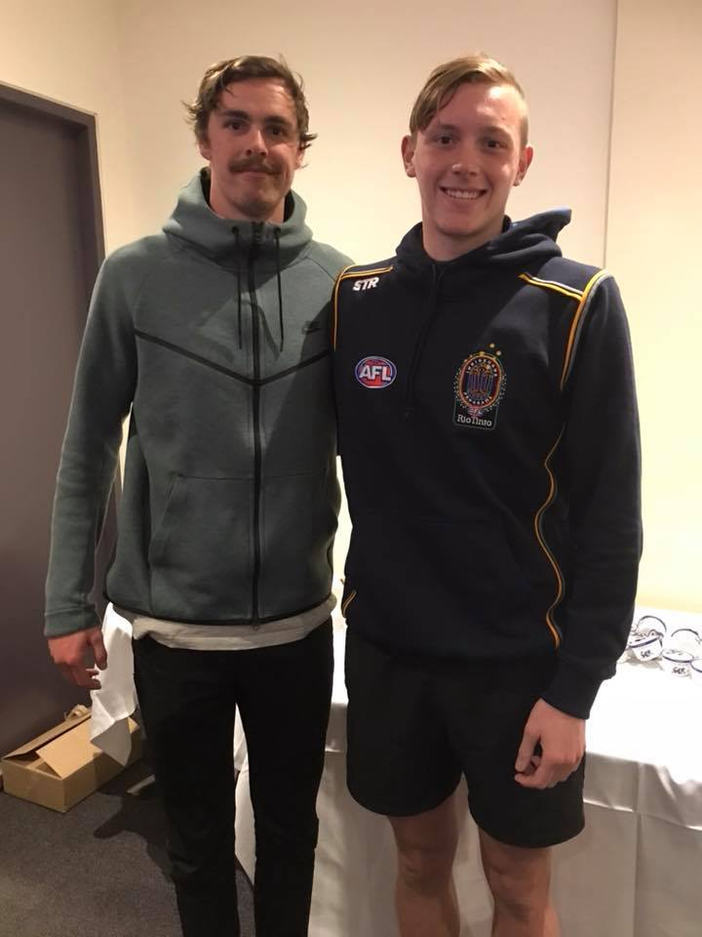

**Big Joe with Joey Daniher**

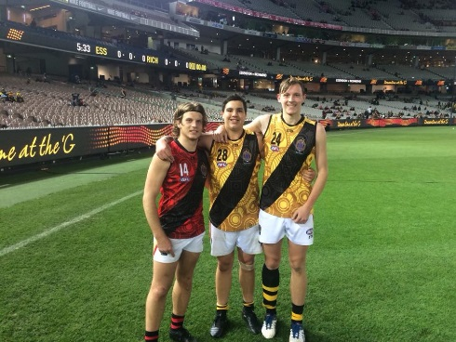

**Joe & his mates on the MCG**

This week everybody from the Port Cygnet Football club looks forward to the Queen’s Birthday long-weekend and the bye and a chance to get over some niggling injuries, and a good rest for our tireless volunteers. We then recharge our batteries the weekend after as we welcome the Sorell Eagles to Cygnet Oval.

**Support The Port in 2018**