PORT GETS WIN OVER A GALLANT BRIGHTON
The Port Women kicked off last weekend’s games with a tough Friday evening contest against Lindisfarne, while the Cygnet men travelled to Brighton to take on the Robins. The Southern Storm Colts had the bye round and the week off.
Port Women:
On a chilly Friday evening, the Port Women travelled to Anzac Park to take on second-placed and one of the flag favorites, Lindisfarne.
The Port were a little undermanned due to late season injuries and a few battling sickness, but despite this the Port came out full of enthusiasm and ready to take on a quality team who had won 12 of their 13 games this season.
The first half saw plenty of action in the Ports backline, with Keren Scotney leading from the back and helping to limit the scoring opportunities for the home team. At quarter time the Blues had opened up a 26 point lead. It was more of the same in the second term, as Lindisfarne continued to attack while making forward entries difficult for the Port. The margin at half-time was out to 47 points.
The third quarter saw the Port step it up a notch, with the midfield working hard to get the ball up forward and a great team effort was rewarded with the Ports first goal of the game, kicked by Emily Direen.
The midfield continued to work hard, with Michelle Cowen winning a lot of the ruck contests and with standout efforts from Cait Scullin, Tia Duggan, Hayley Flakemore, Serena Hubert and Annaliese Dance, the Port was able to put in a huge second half and restricting Lindisfarne to four goals only for the half. The finals score was Lindisfarne 11-9-75 to the Port 1-0-6.
Coach Renee Schuettpelz commented that naming the six best players was incredibly hard as everyone played extremely well, with some players playing completely out of their normal positions. But the best on went to: Hayley Flakemore, Serena Hubert, Mattia Duggan, Cait Scullin, Anna Stanway and Annalise Dance. Emily Direen kicked the Port’s only goal.
Seniors:
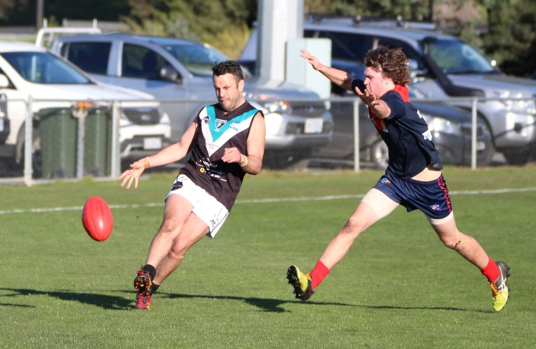
A nice sunny Saturday greeted the Cygnet Senior and Reserve teams as they journeyed to Brighton for their first hit-out in three weeks. The Port welcomed back into the team 2017 Best & Fairest Winner, Sam Dean, fresh from his overseas travels and Corey Polley also made his way back into the team after a long term injury. Coach Ben Cato was a non-starter due to back soreness.
Both midfields started the game well with each winning their share of the centre clearances in the first quarter. Despite dominating the inside 50’s, unfortunately for the Port they were very wasteful in front of goal. Very early on the Port seemed a little off their game and it was the barest of margins separating the two teams at the first break, with each team having kicked 3 goals for the quarter.
Jeremy O’Neill gets his kick away
The second quarter saw the Port take control of the centre clearances as a result of some great ruck work by young Jack Brereton, who continued to give his Port midfielders first use of the ball. The inside 50’s were again dominated by the Port but some ordinary delivery into the forward line meant that the Robin defenders were able to intercept with ease. At half-time the scores were locked at 6-6-42 apiece.
With Coach Cato pleading for more from the boys, the Port came out in the third quarter and once again dominated the centre clearances and the inside 50’s. Delivery into the forward line finally improved and the Port forwards were able to capitalise, kicking four goals in this quarter while restricting their Brighton opponents to one goal only. The Port had opened up a three goal buffer at the three-quarter time break.
The final quarter followed the same story line, with the Port dominating the centre clearances and inside 50’s and again added to their scoreline, kicking three goals to the Robin’s one goal, to run out victors by 31 points.
Joe Direen presented well all day to end up with 6 goals, while Ben Halton again impressed with a dominant display in the forward half, finishing the game with 3 goals.
Jackson Gordon, Toby Cowen, Rhys Jennings and Jack Brereton all put in solid performances and stood tall when required, giving the Port’s forwards every opportunity. Rhys Jennings, Will Ford, George O’Neill and Jake Dance were the Port’s other goal scorers.
Reserves:
After displaying inconsistent and indifferent form in recent weeks, Saturday’s game was an opportunity for the Port Reserves to finally put together a four quarter performance against a struggling Brighton squad. Despite not playing for three weeks, the Port came out blazing, kicking eight first quarter goals while holding their Robin opponents scoreless. Will Polley, playing his first game after an extended absence due to injury and school football commitments, dominated the ruck contests all day, setting up his onballers who constantly drove the ball forward to the Port forwards.
The second quarter was a tighter affair with Brighton putting in a strong effort to restrict the Port to two goals only, with the margin out to eleven goals at half time. It was an avalanche of goals for the Port forwards in the third term, where they kicked nine goals while the Port midfield and defence worked hard to again keep the hapless Brighton scoreless. Brighton kicked three last quarter goals but the damage had already been done and the Port ran out comfortable winners by 136 points.
Better players in a complete team performance were Will Polley, Aaron Dance, Mark Bradley (3 goals), Paddy O’Neill (2 goals), Joel Davey (2 goals) and B. Sculthorpe.
In a pleasing effort, the Port had eleven goal scorers for the game, with the wily veteran Ollie Burke snagging 5 goals. Others to hit the scoreboard were Jack Bester 3, Marcus Coulson 3, birthday boy Shane Clark 2, Brandon Lane, Matt Coulson, Jack Brett and Chris Stockfeld.
This week’s games
This Saturday the Cygnet Seniors, Reserves and Southern Storm Colts will again be on the road, travelling to Lindisfarne in what promises to be three really challenging games for the Port.
The Port Women have the bye this weekend and a much-deserved rest before their final game against New Norfolk at the Lindisfarne Gala Day on Sunday August 12th.
Past Players Function
Tickets are now on sale for the Past Players, Official and Supporters function to be held on Saturday 11th August. The guest speaker will be local identity Tony ‘Boots’ Marchant.

