BIG DAY FOR ‘THE PORT’ ON AND OFF THE FIELD!!
It was a big day at Cygnet last Saturday, with three wins and a very successful Past Players and Supporters Function.
Over 150 past players, officials and supporters of the ‘Cygnet Community Bank Football Club’, as well as guests from other HFA Clubs, enjoyed their annual get-together, with former Hawthorn and Gold Coast player, Campbell Brown, a most entertaining guest speaker. This year’s function commemorated the 40th anniversary of Cygnet’s 1976 Senior Premiership win and it was great that several members of that team were able to be present and were joined by Haydyn Nielsen (Grand Final Umpire) and Ashton Denehey, who played for the opposition Channel team in the Grand Final.
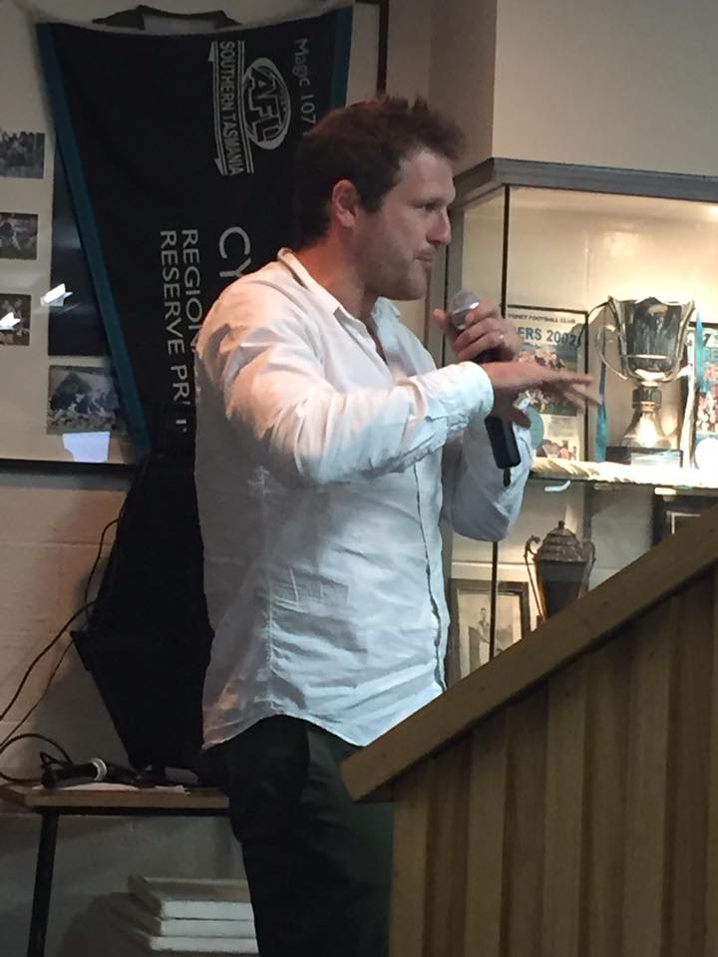
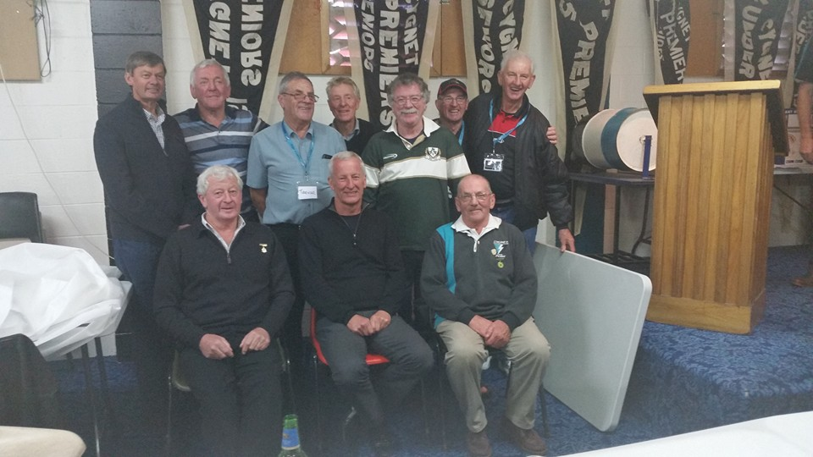

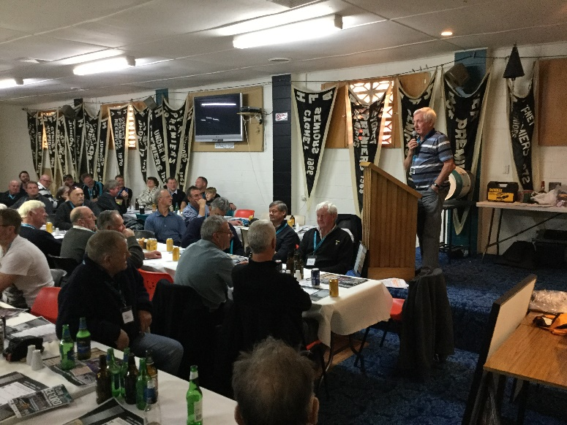
Other speakers on a day full of laughter and conviviality, included Club President, Dave O’Neill, Senior Coach, Gav Quirk, Past Players Committee President and 1976 team member, ‘Tidsy’ Smith and 1976 Senior Captain-Coach, Brian ‘Gormo’ Dillon.
A highlight of the day was the awarding of Past Players Committee Life Membership to John Synnott in recognition of his excellent contribution to the Past Players annual function over the 13 or so years since the event was first introduced.
During the function, ‘Tidsy’, on behalf of the Past Players Committee, presented the Club with a cheque for $2,200 to assist with the purchase of floor coverings for the new change rooms. These funds, together with monies generously donated by the Southern Storm and Cygnet Mini-League Clubs, will help complete the internal fitout of the rooms. The Past Players Committee expressed their gratitude to all the day’s sponsors who so generously donated raffle prizes or refreshments. A special thank you also to Trent and Michelle Cowen of Abel Labels and Cowen’s Drapery, whose significant contribution helped get Campbell over as the guest speaker.
It was also a positive day on the field, with all three teams having success. In perfect sunny conditions, the Southern Storm boys were matched against arch rivals Brighton, who had won six out of their eight games and were keen to atone for their narrow loss to the Storm earlier in the season. After a very tight and low scoring first half, the Storm held a slender one goal lead at half-time. With Coaches Matty Brereton and ‘Squid’ Gordon encouraging the boys to move the ball quickly, the third quarter saw the Storm kick four goals to two to extend their lead to 20 points with a quarter to go. The last quarter was more of the same with the Storm outscoring their Robin opponents to run out comfortable winners by 29 points.
Better players in another very good all-round team effort were Jackson Gordon (4 goals), Liam O’Neill, Peter O’Neill, Paddy O’Neill, Toby Cowen and Brandon Lane. Joe Direen, who had earlier in the week played for the State Under 17 side in Launceston, contributed another 2 goals to take his season tally to 32 goals and retain his lead in the Colts competition. Toby, Brandon and Jack Bester were the others to hit the scoreboard.
After disappointing performances against Hobart and Lindisfarne in their previous two games, ‘Stick’s Clark and his Reserve boys were keen to reverse the trend and take it right up to Sorell. Cygnet got off to a great start and completely outplayed the Eagles in the first quarter kicking five goals whilst keeping their opposition scoreless. The second quarter saw Sorell start to get their game going and they had reduced the lead to four goals at half time. Shane Clark, Brad Carver and Tim Bakes were all getting amongst the goals, but Sorell were not done yet and reduced the lead to only three goals with an exciting last quarter looking likely. Indeed it was goal for goal in the last term, with the Port hanging on by 16 points for a much-needed third win of the season.
Coach ‘Stick’s lead from the front with 4 goals, and he was well supported by Brad Carver and Tim Bakes (each with 3 goals), Joe Shields, Darcy Millhouse and Paddy Wilcox. Tyler Cowen was the other goal scorer in a much-improved team performance.
With a large crowd of past players, officials and supporters looking on, the Seniors were also keen to put aside the previous week’s performance against Lindisfarne and get back on the winner’s list. It was also an important milestone game for two highly respected team mates, with Micheal ‘Pud’ Darcy and Matty Dance playing their 250th and 200th Club games respectively. A great achievement guys, well done.
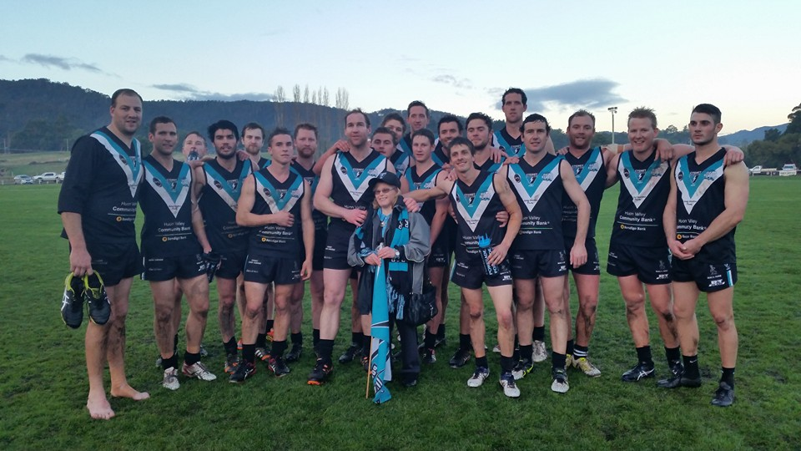
Unfortunately the game did not start too well for the Port, with Grant ‘Noodles’ Clark injuring his hamstring in the first 30 seconds and he was unable to take any further part in the game. Despite this setback, the Port were soon on the board and a four goal to three quarter gave Cygnet an 11 point lead at quarter time. The Port’s three-pronged attack of Ben Halton, ‘Pud’ Darcy and Jason Laycock was worrying the Sorell defence and an excellent 6 goal second quarter extended Cygnet’s lead to 28 points at half time, which could have been greater but for inaccuracy in front of goal.
Sorell had slightly the better of the third quarter and the lead at the final break was an even four goals. The Eagles then challenged strongly in the final term and it looked like another ‘nail biting’ finish was on the cards. However late goals to Jason Laycock and Brayden Hayes sealed the win for the Port by 24 points. It was certainly not a convincing win, but the boys had done enough to get over the line.
Will Ford was supreme at Full Back all day and topped his game off with a great goal. Ben Halton was again a key focal point with six valuable goals and Chris Nield showed the form we were expecting. Other good contributors were Jake Brereton, whose high marking was again a feature, Mitchell Direen’s run off half back set up many scoring opportunities, while Brad Watson was his usual hard at it in the contests getting many possessions and clearances.
Other goal scorers were ‘Pud’ Darcy, who kicked 3 goals in his 250th game, Jason Laycock and Brayden Hayes each with two goals and singles to Chris Nield, Gav Quirk and Will Ford.
This week the Port are again at home, when we play second-placed Claremont who have only lost the one game this season and that was to the undefeated Lindisfarne. The Claremont Reserves are undefeated and their Colts have also only lost the one game. All Cygnet and Southern Storm teams will really need to be switched on if we wish to take the game up to Claremont. But on our home ground and in front of a large parochial Cygnet crowd, anything is possible.
Get along to the footy this Saturday and cheer on The Port and the Southern Storm lads.
QUIZ NIGHT THIS SATURDAY
Don’t forget the Quiz Night this Saturday night at the Clubrooms following the Claremont game. Get your team together (up to 6 members per team) for another great social function at the Club. Check out our Facebook page for further details.
Major Sponsor: Cygnet ‘’Top’’ Hotel
Naming Rights Sponsor: The Huon Valley Community Bendigo Bank
Associate Sponsors: Tascon, Duggans Pty Ltd, Southern Smash Repairs, Abel Labels, Cowen’s Drapery, Cygnet Water Cartage, Cygnet Newsagency, Cygnet Building and Joinery, Farah’s IGA Everyday, Elite Painters, B&T Glass, Robert Armstrong MLC, Mal’s Hire & Hardware, Luke Synnott Excavations and Contracting, Aaron Gordon
Weekly Award Donors: Phillip & Loretta Wilcox [Wilcox Electrical], Bill Cribbin’s BP Cygnet, Roys Bits of Old Pizza and R & D Meats
‘’Support the Port in 2016’’

