CLAREMONT PROVE TOO GOOD FOR ‘THE PORT’
The ‘Cygnet Community Bank Football Club’ hosted Claremont last Saturday, as the SFL started its second round of roster matches. After three wins the previous week The Port were looking to take up the challenge against their highly-ranked opponents. However, it was not to be, as Claremont were comfortable winners in all three games, with similar margins of around nine goals.
After a cold and frosty start to the day, the sun came out and with no wind evident, the conditions were perfect for football. The first quarter of the Colts game was a fairly even affair with Claremont leading by 11 points at quarter time. Claremont really switched on in the second quarter to kick 5 unanswered goals to open up a handy seven goal lead at the half-time break. Whilst the Storm battled hard in the second half with a much more focussed team effort, they were unable to bridge the deficit, eventually going down by 55 points.
Better players were Jack Brereton who toiled manfully in the ruck, Jack Bester around the ground and with two goals, Jake Munnings, Hallam Blacklow, Sean Burgess and Bryce Webster. Other goal scorers were Joe Direen (two goals), with singles to Kye Stokoe and Scott Blacklow.
Once again Cygnet’s Reserves got off to a good start taking the game right up to the undefeated Claremont side. Inaccuracy was letting Claremont down and The Port held onto a one point lead at the first break. However after quarter time it was all Claremont, as they got their running game going, kicking nine goals to Cygnet’s one goal to run out winners by 53 points. Despite the loss, it was a much improved performance by ‘Sticks’ and his boys, who had been soundly beaten by Claremont by 135 points earlier in the season when they had failed to score.
Elliott ‘Twiggy’ Ross, ‘Sticks’ Clark, Adam Direen, Brendan Dare, Tommy Slevin and Tim Bakes battled hard all day whilst Reece Polley and Tim Bakes were the only ones to bother the scorer.
The Seniors were without Grant Clark due to an injured hamstring and last year’s Best & Fairest winner, Braden Hayes, who was unavailable due to his selection in the Tasmanian Under 23 team who played Western Australia in Launceston last Sunday.
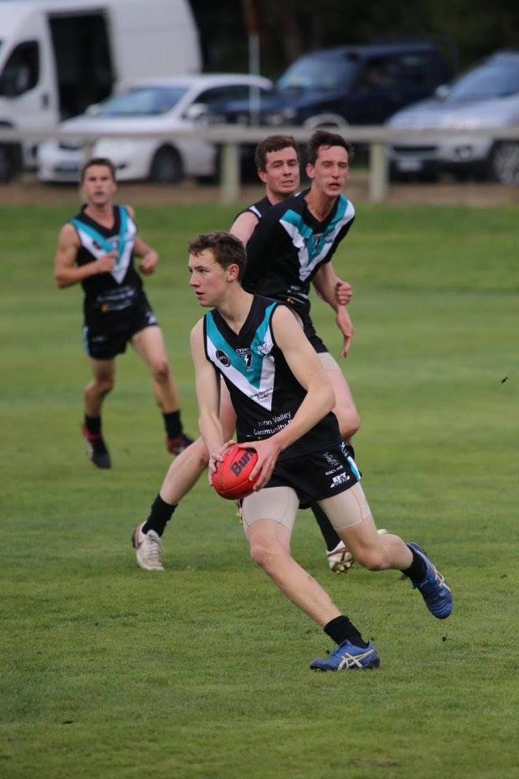
Congratulations Brayden on your selection and the opportunity to represent your State at the highest level. Young Jackson Gordon was promoted for his first senior game after playing some excellent football for the Southern Storm Colts. Well done Jackson and we all hope that this will be the first of many senior games you will play with the Cygnet Football Club.
Cygnet were on the scoreboard early and matched it with Claremont for most of the first term before several late goals gave the visitors a handy five goal lead at quarter time. The Port came out far more determined and focussed in the second quarter and with young Toby Cowen showing considerable poise around goals and with the three-pronged attack of ‘Pud’ Darcy, Ben Halton and Jason Laycock working well, Claremont’s lead was reduced to one goal at half time.
However, one quarter of quality football will never be enough to remain competitive against top sides such as Lindisfarne and Claremont. The third or ‘premiership’ quarter was all Claremont’s as they moved the ball with precision and seemed to find their forwards either by themselves or one-out on most occasions. They kicked 9 goals whilst holding The Port scoreless. Although Cygnet outscored the Magpies in the final quarter the damage had well and truly been done, with the final margin being 56 points to the visitors.
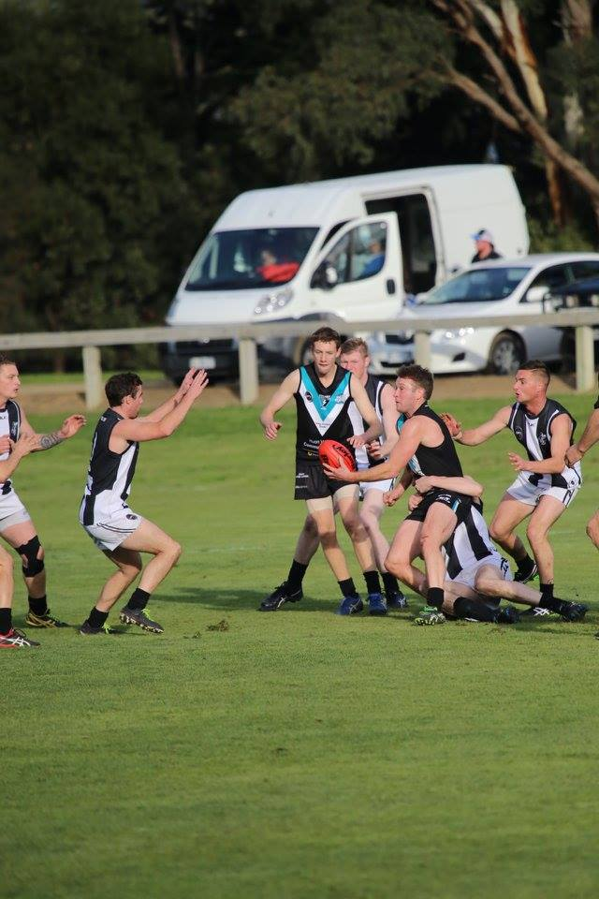
Bradley Watson played probably his best game of the season with many hard fought clearances and strong bullocking work around the stoppages. Will Ford battled manfully against several forward opponents, Toby Cowen showed he will be a player of the future with quality possessions and two valuable goals, whilst ‘Pud’ Darcy was the key target kicking five goals. Another Colts player, Brandon Lane got plenty of the ball as did Matty Dance.
Ben Halton kicked two goals ‘on one leg’ with singles to Rhys Jennings, Brandon Lane, Gav Quirk, Brad Watson and Jackson Gordon topped off a very commendable first game with a great set shot for goal late in the game.

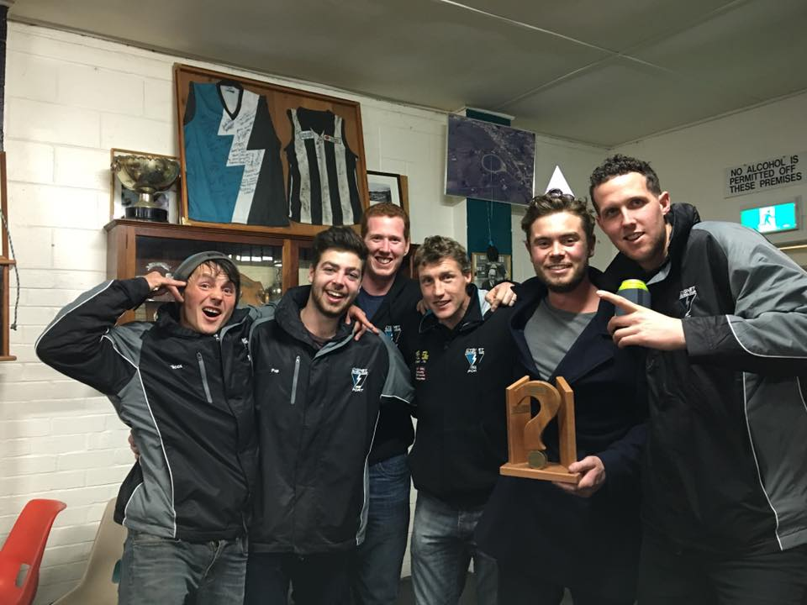
A MOST ENJOYABLE QUIZ NIGHT
The Quiz Night last Saturday night was another great fun night, with 12 highly competitive teams chasing the title of Quiz Champions. Bragging rights went to the “Will Jules Pat Brereton’s Pup” team of Will Ford, Jules Direen, Patty Wilcox, Gerard and Chris Brereton and Josh Doyle. Thanks to Quiz Master, Stu Eaton, MC ‘Sticks’ and our excellent Social Committee for organising another successful and fun night.

NO FOOTBALL THIS WEEKEND
There will be no SFL games this weekend due the League’s mid-season bye. The following Saturday (18th June) The Port will travel to Pontville to take on Brighton.
Major Sponsor: Cygnet ‘’Top’’ Hotel
Naming Rights Sponsor: The Huon Valley Community Bendigo Bank
Associate Sponsors: Tascon, Duggans Pty Ltd, Southern Smash Repairs, Abel Labels, Cowen’s Drapery, Cygnet Water Cartage, Cygnet Newsagency, Cygnet Building and Joinery, Farah’s IGA Everyday, Elite Painters, B&T Glass, Robert Armstrong MLC, Mal’s Hire & Hardware, Luke Synnott Excavations and Contracting, Aaron Gordon
Weekly Award Donors: Phillip & Loretta Wilcox [Wilcox Electrical], Bill Cribbin’s BP Cygnet, Roys Bits of Old Pizza and R & D Meats
‘’Support the Port in 2016’’

