MIXED RESULTS FOR ‘THE PORT’ AGAINST BRIGHTON
Last Saturday saw mixed results for the ‘Cygnet Community Bank Football Club’, with two losses and a win from their trip to Pontville to take on the Brighton Robins.
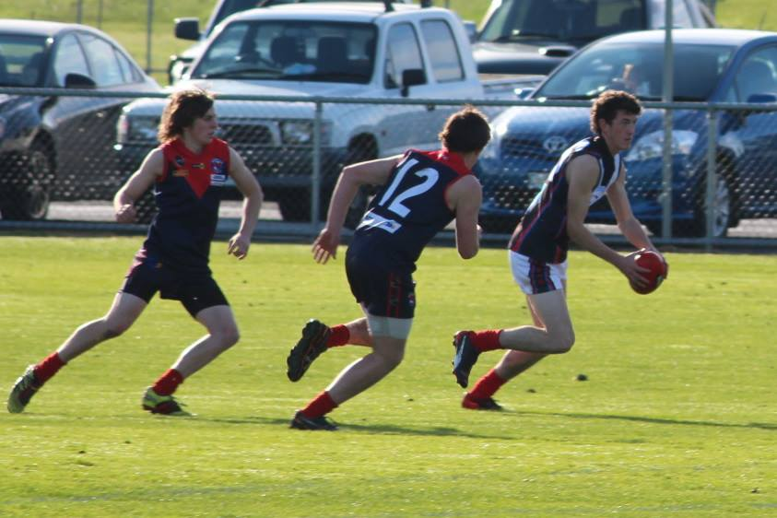
In perfect, sunny conditions, the Colts game promised to be another close affair, after only six points separated the two teams when they met previously in round 3. With plenty of pressure being exerted early by both teams, scoring was difficult, resulting in only two goals each for the first quarter. The play opened up a bit in the second term with both the Storm and Brighton each scoring four goals, and with the Robins holding a two point lead at half time. Joe Direen was again proving a headache for the opposition defence and the Storm’s on-ballers were taking it up to their bigger opponents. After half time, Brighton got out to a two goal lead but a late goal had the Storm only nine points down with a quarter to go. The Storm had most of the play in the final quarter until a serious shoulder injury to Jack O’Neill halted the game for several minutes whilst Jack was helped from the ground. When play resumed the Storm continued attacking and despite a late goal from Elijah Reardon they simply ran out of time, going down by a solitary point.
Better players in a very even team effort were Peter and Liam O’Neill, Bryce Webster, Joe Direen (4 goals), Jack Brereton and Jackson Gordon. Elijah Reardon finished with two goals, while other goal scorers were Jack Bester and Jackson Gordon.
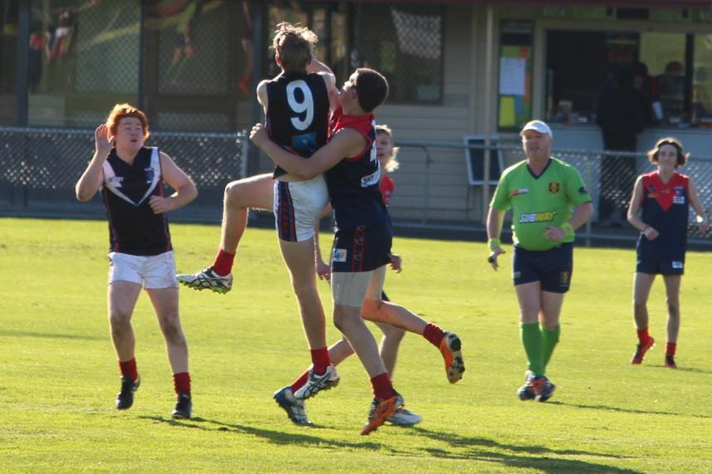
All at the Club wish Jack a speedy recovery from his fractured scapula (shoulder blade) and look forward to seeing his smiling face back on the track very soon.
After ten games, the Storm sit in fourth spot on the ladder on percentage, but with the Huonville Lions and Dodges Ferry breathing down their neck and both having only played nine games. Playing good consistent team football over the coming weeks will be critical if the Storm are to stay in the finals’ race.
(Photos courtesy of Ash Munnings)
The Cygnet’s Reserves were never in the hunt against second-placed Brighton, who jumped the Port boys right from the first bounce. After a nine goal to nil first half, the Robins held a comfortable 59 point lead at half time. Despite Coach ‘Sticks’ Clark imploring his men to get involved and be more accountable, the second half was a repeat of the first, with Brighton running out comfortable 130 point winners over a very disappointing Cygnet.
Jules Direen, showing his vast experience, knocked up getting kicks across half-back and was clearly the Port’s best player. Paddy Ford, Joe Shields, Jarryd Atkins and Brandon Lane all tried hard but just didn’t receive enough support from their team mates. Daniel Walter was the only one to trouble the scorers. A general lack of fitness really shows up when quality opponents create turnovers and then move the ball quickly from one end to the other and score at will. The boys have previously shown that they can be competitive, but a commitment to training and playing for each other is a must if we are to get any further wins. So get behind ‘Sticks’ boys and let’s all hit the track this week.
After three losses in their past four games, the Port Seniors were keen to get back on the winner’s list with a strong performance against Brighton. The Port were missing ‘Pud’ Darcy, Grant Clark and Matty Dance from their line-up, but welcomed ex-North West Coaster, Tim ‘Bossa’ Bakes, into the side for his first senior game.
From the very first bounce Brayden Hayes was in everything and proving a live-wire across half-forward, whilst Jason Laycock was ‘clunking’ his marks and providing a real focal point. After an even first quarter, Cygnet held a two goal lead which they extended to three goals at the long break. After half-time, the Port really got their game going, with Mitchell Direen breaking the lines from half-back and Laycock, Ben Halton and Haysey hitting the scoreboard often, the Port’s lead increased to 31 points at three quarter time.
With Coach Gav Quirk urging a ten goal victory to lift the team’s poor percentage, the Port machine really rolled in the final term, playing some of their best football for the season. With Jake Brereton winning the centre taps and Chris Nield and Bradley Watson driving the ball long time after time, it was another six goals to three quarter, with the final margin being 52 points in Cygnet’s favour.
In one of the most dominant displays of contested marking seen for some time, Jason Laycock was unbeatable in the air, taking around 25 marks for the day, finishing with four goals and a hand in several others. Brayden Hayes again showed his class and why he was recently selected in the Tasmanian Under 23 side, finishing with a game-high five goals. Other fine contributors in an excellent overall team effort were Bradley Watson and Chris Nield, particularly in the second half, Mitchell Direen and Jacob Brereton. Other goal scorers were Ben Halton (3 goals), Gav Quick, Josh Doyle and Elliott Ross (2 goals each) with singles to Watto, Nieldy and Jacob B.
NEW NORFOLK ARE OUR OPPONENTS THIS WEEK
This week we again take a road trip, to Boyer Oval to take on the New Norfolk Eagles. After a slow start to the season, the Eagles have now won three of their last four games and are always hard to beat on their home turf. All three Port teams will need to be right on their game if we are to bring home the victories and for the Seniors to consolidate third place on the ladder.
LADIES LUNCH SATURDAY JULY 2nd
Ladies, don’t forget the ‘Ladies who Lunch’ function will be held on our next home game, against Huonville, on Saturday 2nd July. The day kicks off at 11am and the cost is only $25 which includes lunch, champagne and lucky door prizes. Tickets are available from Brigid (0437 002 960) or Jayne (0427 104 173). Come join us for some bubbles and banter and loads of fun.

Major Sponsor: Cygnet ‘’Top’’ Hotel
Naming Rights Sponsor: The Huon Valley Community Bendigo Bank
Associate Sponsors: Tascon, Duggans Pty Ltd, Southern Smash Repairs, Abel Labels, Cowen’s Drapery, Cygnet Water Cartage, Cygnet Newsagency, Cygnet Building and Joinery, Farah’s IGA Everyday, Elite Painters, B&T Glass, Robert Armstrong MLC, Mal’s Hire & Hardware, Luke Synnott Excavations and Contracting, Aaron Gordon
Weekly Award Donors: Phillip & Loretta Wilcox [Wilcox Electrical], Bill Cribbin’s BP Cygnet, Roys Bits of Old Pizza and R & D Meats
‘’Support the Port in 2016’’

