GOOD WINS TO ‘THE PORT’ SENIORS AND ‘SOUTHERN STORM’ COLTS
Last Saturday, the ‘Cygnet Community Bank Football Club’ journeyed to the TCA Ground to take on the Hobart Tigers, with all three matches critical to the Club’s final aspirations.
A boggy ground after the recent heavy rain and a strong wind favouring the bottom grandstand end of the ground meant that all teams had to be smart in how they approached their game plan. Long attacking football with the wind and strong and tight defence were the order of the day.
The Southern Storm Colts were keen to atone for their disappointing performance against Dodges Ferry the previous week and were quickly out of the blocks, scoring six goals to one against the wind in the first quarter. Once again Joe Direen and Jake Dance were providing good avenues to goal. A further five goals in the second quarter gave the Storm a handy ten goal lead at half-time. With Coaches Matt Brereton and ‘Squid’ Gordon urging the boys to run and move the ball quickly, the game really opened up in the second half with the Storm kicking six goals to one in each quarter to run out convincing winners by 129 points.
In a much improved four quarter team performance, better players were Kyle Russell, Aza Nichol-Hawkes, Toby ‘Logger’ Cowen, Scott Blacklow, Jake Dance and Jake Munnings. The goals were scored by Joe Direen and Jake Dance (both with five goals), Kyle Russell (2), Jack Bester (2), Jake Munnings (2), Elijah ‘Cyril’ Reardon (2) with singles to Bailey Gordon, Peter and Jack O’Neill. In a fantastic effort, Joe has now kicked 58 goals for the season and increased his lead in the SFL Colts competition to 16 goals.
The Reserves also kicked against the strong wind in the first quarter and in a good effort managed to restrict their Hobart opponents to three goals while kicking one themselves. The second quarter was a reverse of the first with the Port boys scoring four goals to Hobart’s one to take a nine point lead into the half-time break. With Coach ‘Sticks’ Clark urging his players to continue their tight defence, Hobart were able to score four goals in the third quarter while keeping the Port goalless, to regain the lead by 14 points. An early goal by Hobart gave them a handy 20 point lead and despite two late goals the Port boys couldn’t get over the line, going down to a jubilant Hobart by ten points. Unfortunately the loss now has the Reserves in eighth position, a game and percentage out of the top five.
Daniel Donato and Patty Wilcox battled hard all day, along with Corey Shaw who was playing his 150th Club game (congratulations Corey), Jeremy Duggan, Paddy Ford and Kurt Butterworth. Joe Direen, backing up for his second game for the day kicked two goals as did Shane Clark, with Jamie Direen, Jack Bester and Damo Duggan each kicking one goal.
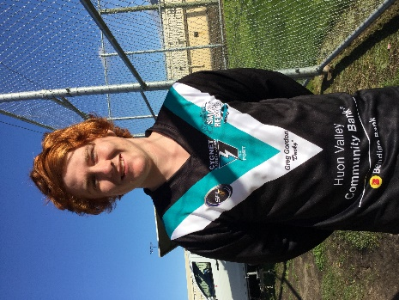
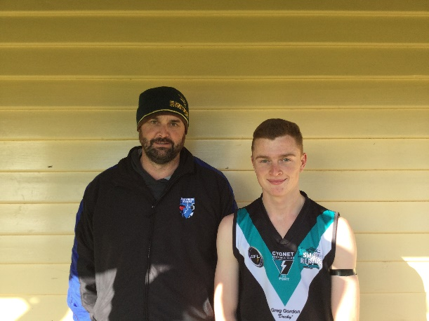
The Seniors welcomed Storm youngsters Nathan ‘Bluey’ Duggan and fellow ranga Liam ‘Lingy’ O’Neill for their first senior game, along with Paddy O’Neill. All three lads have had excellent seasons with the Storm and clearly warranted their promotion and opportunity to showcase their skills at the higher level. Also coming into the team to provide much needed hardness in the midfield were Bradley Watson and Sam Dean, playing his first game for 2016.
The Port got off to a flier in the opening quarter, consistently winning the taps and the centre clearances and kicking the ball long with the breeze into the forward line, where Jason Laycock was dominating. By the 16 minute mark ‘Cocky’ had clunked five marks and kicked truly for five goals. Brayden Hayes was running amok both in the centre and up forward and he also got a couple of early goals. Another highlight of the quarter was the superb left foot snap goal by debutant ‘Lingy’ O’Neill, with his first kick in senior football. It was a ten goal quarter for the Port to lead by over 50 points. The challenge was to hold off the Tigers who now had the aid of the strong breeze in the second quarter. With Ben Halton and Jake Brereton assisting across half-back the Port defence were able to keep Hobart goalless while Bradley Watson and Mitchell Direen were instrumental in continually driving the ball forward, where Cygnet was able to kick four goals into the breeze. A further seven goals to Cygnet to the Tiger’s two in the third quarter gave the Port a handy 112 point lead at three quarter time. The last quarter was a more even affair as Hobart kicked four goals to the Port’s five goals straight, with the final margin being a percentage boosting 115 points.
Jason Laycock was superb all day with his marking again a highlight and finished with eight goals and Brad Watson had a great return and knocked up winning the hard ball and provided pinpoint delivery to his forwards. Brayden Hayes ran hard and continually broke the game open finishing with five goals, while Mitch Direen continued his excellent form with his run off half-back.
First-gamers Nathan Duggan and Liam O’Neill (2 goals) both impressed in their debuts, with their clean ball handling, good decision making and disposal skills both by foot and hand. The signs are really good for the future of the Club as these young man and the several other Storm players who have played senior football all show tremendous promise. Well done boys.
Others to hit the scoreboard were Ben Halton (2), Will Ford (2), Matt ‘King of the Rangas’ Cane (2), Gav Quirk (2), Brad Watson (1), ‘Pud’ Darcy (1), Jake Brereton (1) and Rhys Jennings (1). The win moves the Seniors into third position, a game ahead of the Huonville Lions and New Norfolk, but with the latter still having an extra game to play.
LINDISFARNE AT HOME THIS WEEK
This week the Port will host the Lindisfarne Two Blues at home, in what promises to be hard fought contests. Both Cygnet teams must be switched on and ready to play if they are to get the spoils over their highly-ranked opponents.
In what seems strange rostering, both the Southern Storm and Lindisfarne Colts teams have a bye this weekend.
Make sure you get along to the footy this Saturday to support the Port boys.
AUSTRALIAN LAMBASSADOR AT THE SPORTMAN’S NIGHT THIS SATURDAY (23RD JULY)
Tickets are still available for this Saturday night’s Southern Smash Repairs Sportsman’s Night, where AFL North Melbourne legend and Australian Lambassador, ‘Slammin’ Sam Kekovich, will be the guest speaker. In what promises to be another great fun event, there will also be a Memorabilia Auction and Live Raffle. For further details check out our website (cygnetfc.com.au) or Facebook pages, or contact Shane Clark on 0429 132 762.
Come along and support the Port in this major fundraising event for the year.

Major Sponsor: Cygnet ‘’Top’’ Hotel
Naming Rights Sponsor: The Huon Valley Community Bendigo Bank
Associate Sponsors: Tascon, Duggans Pty Ltd, Southern Smash Repairs, Abel Labels, Cowen’s Drapery, Cygnet Water Cartage, Cygnet Newsagency, Cygnet Building and Joinery, Farah’s IGA Everyday, Elite Painters, B&T Glass, Robert Armstrong MLC, Mal’s Hire & Hardware, Luke Synnott Excavations and Contracting, Aaron Gordon
Weekly Award Donors: Phillip & Loretta Wilcox [Wilcox Electrical], Bill Cribbin’s BP Cygnet, Roys Bits of Old Pizza and R & D Meats
‘’Support the Port in 2016’’

