ATROCIOUS CONDITIONS AS ‘THE PORT’ HOSTED LINDISFARNE
Rain, sleet, frequent snow showers and a boggy ground were the order of the day last weekend when the ‘Cygnet Community Bank Football Club’ played host to unbeaten SFL ladder leaders, Lindisfarne. With the Southern Storm Colts having a bye, the two matches played were both critical to the Port’s final’s aspirations.
The Reserves welcomed several Colts players into the team and the enthusiasm and ‘head over the ball’ attitude of these boys was clearly noticeable as they confidently stepped up against a strong Lindisfarne team, who were in second place on the ladder. Lindisfarne scored the only goal of the first quarter to lead by eight points at quarter time. The Cygnet boys started to get their team work going in the second term and managed to score two goals to nil to lead by two points at half-time. With Coach ‘Sticks’ Clark urging his players to continue working hard and put pressure on their ball carriers, the Port kicked two goals in the third quarter to extend their lead to 13 points in what was a very low scoring game. It was a similar story in the last quarter with Cygnet’s two goals to Lindisfarne’s three behinds giving the Port team a well-deserved 22 point victory.
Jamie Direen (2 goals) provided an excellent target up forward and was also effective in the stoppages and getting the ball to his smaller teammates. Corey Shaw, Jarryd Atkins, Tyler Cowen and Paddy Wilcox also contributed well in the difficult conditions. Southern Storm youngster, Jake Dance had an impressive game and was not afraid to mix it in the stoppages with bigger Lindisfarne opponents. He also kicked a goal, as did fellow-Stormer Jack Bester, Shane Clark and Paddy Wilcox.
The win has the Port Reserves outside the final five on percentage, but needing to score wins in their remaining three games (Sorell, Huonville and Hobart) to ensure a finals spot.
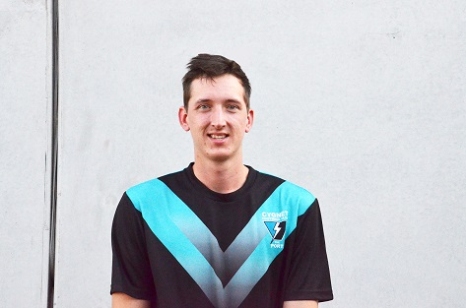
The Seniors were missing Jason Laycock and Bradley Watson due to general soreness but were keen to do well against their top of the ladder opponents and to celebrate Jacob ‘Bubbles’ Brereton’s 100th Club game for the Port. The first quarter was a tight and low-scoring affair with goals to ‘Pud’ Darcy and Brayden Hayes giving the home team a 6 point lead at the first break. The weather worsened in the second quarter with a snow shower and muddy conditions making it difficult for both players and spectators alike. A goal each for the quarter had the Port in front by four points at half-time and it was still anyone’s game.
Lindisfarne came out firing in the third term and a couple of early goals to the bottom end had them back in front before a third goal to Cygnet’s nil score for the quarter increased Lindisfarne’s lead to 26 points at the last break. The Port had most of the play in their forward line in the final quarter but the heavy and slippery ball was making ball movement difficult for both teams and it became a game of constant stoppages and scrimmages. A goal to Josh Doyle at the ten minute mark reduced the margin to 10 points and gave Cygnet a sniff of a win, but it wasn’t to be as Lindisfarne defended gamely to run out victors by 11 points.
Cygnet had a good chance to win the game but it was Lindisfarne’s two quick goals in the third quarter which changed the game in their favour. Sam Dean, in his second game for the season was superb around the packs, winning many of the hard balls, whilst Brayden Hayes also played an in and under role. Gerard Brereton and Mitchell Direen worked hard along with Gav Quirk and Toby Cowen. In a low scoring game the goal scorers were Haysey, Ben Halton, ‘Pud’ Darcy and Josh Doyle.
Cygnet Seniors now sit in fourth position, two games clear of six-placed Hobart, but with all three games remaining considered quite winnable. A final five position is clearly in the team’s own hands.

ONLY ONE GAME THIS WEEKEND
With the Port Senior and Reserve teams having the bye this weekend, only the Southern Storm have a game. Third place, and possibly second spot, will be up for grabs as the Storm Colts travel to ANZAC Park this Saturday to take on third-placed Lindisfarne, with only half a game separating the two teams on the ladder.
Make sure you get along to the footy this Saturday to support Matt, ‘Squid’ and the Southern Storm boys, who are the future of our Club.
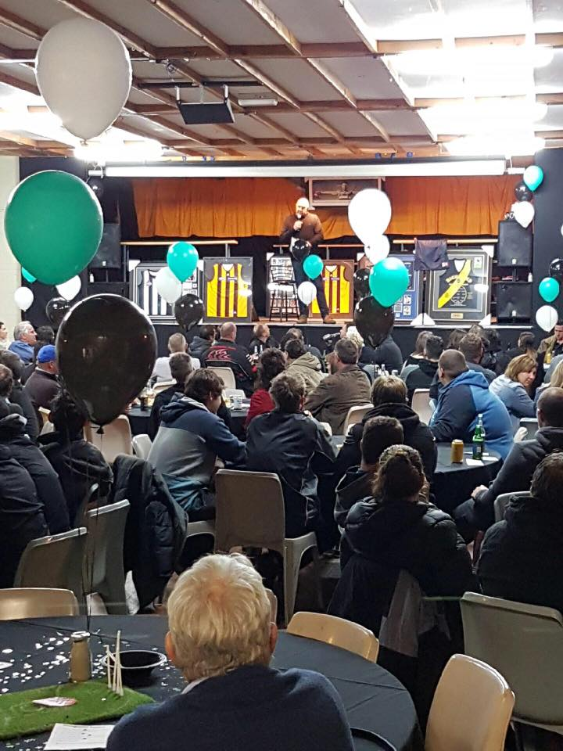
The following Saturday (6th August), the Port Seniors and Reserves will travel to Pembroke Park to play Sorell, while it will be the Storm who has the bye.
SPORTMAN’S NIGHT A GREAT SUCCESS
Last Saturday night’s Sportsman’s Night was a great success, with guest speakers and AFL ‘legends’ Garry ‘Bull’ Baker and Australian Lambassador, ‘Slammin’ Sam Kekovich having the 130 plus in attendance in constant laughter with their reminiscing, storytelling and jokes.
Many thanks to Justin and Rebecca Polley of Southern Smash Repairs and Aaron Gordon and family for generously sponsoring the night, to everyone who donated prizes or brought tickets for raffles and to the generous supporters who brought memorabilia items. The Club would like to sincerely thank Shane ‘Sticks’ Clark and the girls and guys on the Social Functions team who once again did a magnificent job in organising what was both a very enjoyable and profitable night for the Club. Thanks to everyone involved.

Major Sponsor: Cygnet ‘’Top’’ Hotel
Naming Rights Sponsor: The Huon Valley Community Bendigo Bank
Associate Sponsors: Tascon, Duggans Pty Ltd, Southern Smash Repairs, Abel Labels, Cowen’s Drapery, Cygnet Water Cartage, Cygnet Newsagency, Cygnet Building and Joinery, Farah’s IGA Everyday, Elite Painters, B&T Glass, Robert Armstrong MLC, Mal’s Hire & Hardware, Luke Synnott Excavations and Contracting, Aaron Gordon
Weekly Award Donors: Phillip & Loretta Wilcox [Wilcox Electrical], Bill Cribbin’s BP Cygnet, Roys Bits of Old Pizza and R & D Meats
‘’Support the Port in 2016’’

