NEWS FROM THE PORT: GIRLS PULL ON THE BOOTS AND CLUB’S ANNUAL DINNER/TROPHY NIGHT

SFL WOMENS COMPETITION
It has been a busy off-season with the SFL announcing its inaugural AFL Women’s competition in mid-February. With only a few weeks to organise and train a team, the Port took up the cause and was ready to challenge the Claremont Magpies, Hobart City Demons and South East Suns in a round robin competition at Kingston earlier this month.
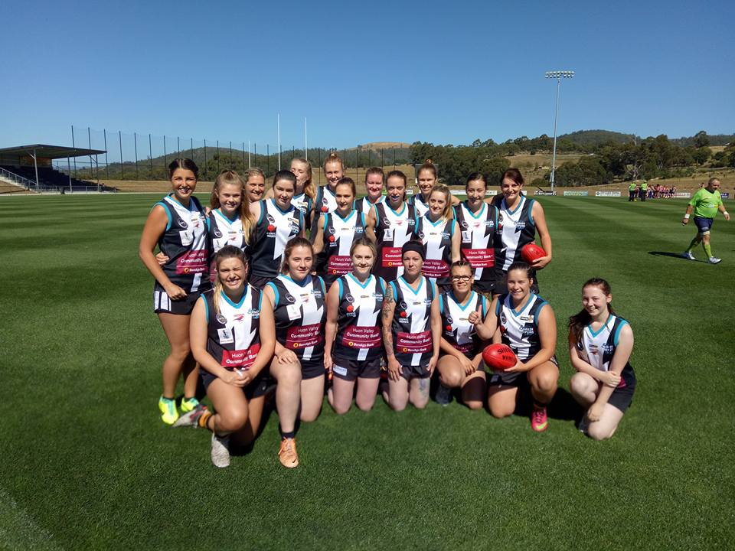
Many thanks to the girls from other parts of the Huon Valley and Kingborough who joined with those from the Port to make up a formidable combination. The Port’s first game of the competition was against the Magpies and in an excellent team performance the Port kicked seven goals whilst restricting their opponents to one point, to run out comfortable winners. The second game was a more closely fought contest, with the Port going down narrowly by 2 points to the Demons.
In their final game of the day, the experienced Suns team were too strong for the tiring Port girls, winning by 4 goals. Although there were many tired and sore girls after the three games, it was a great day to kick off the SFL women’s football competition.
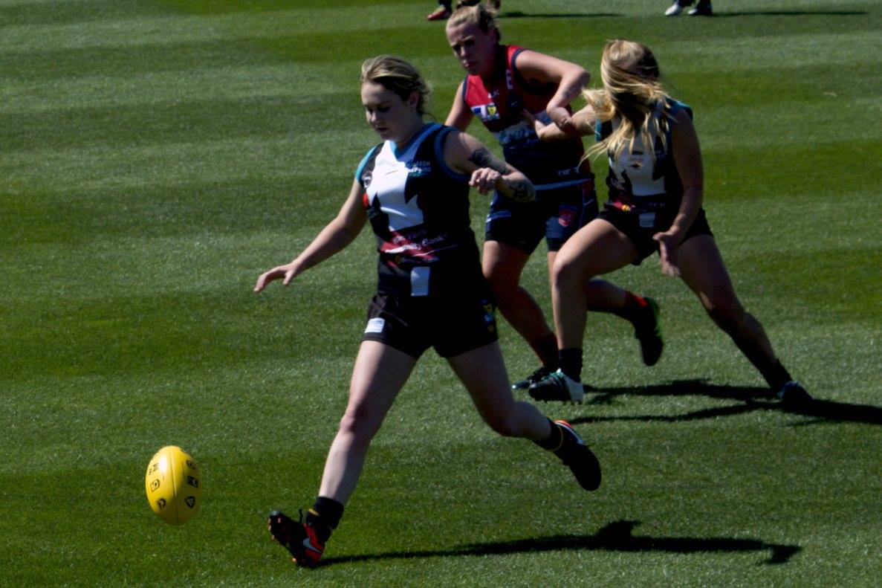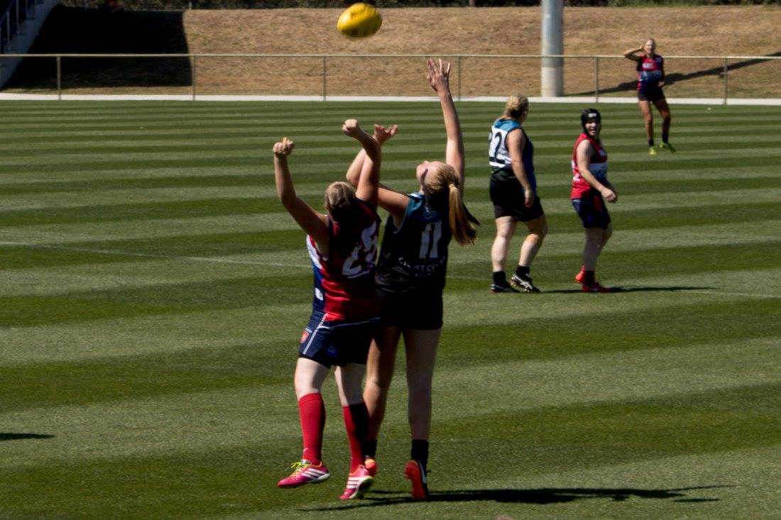
CFC ANNUAL DINNER AND TROPHY NIGHT
The Club recently held its 2016 Annual Dinner and Trophy Presentation, which wrapped up a very successful season for the Port. Our Club photographer and supporter Carolyn Whitehouse was present to take the ‘red carpet’ shots and with MC Will Ford keeping everyone entertained, and DJ Mark Direen on the music, a great night was had by all.
Southern Storm Colts Coach Matt Brereton started the formal proceedings by thanking his boys for their tremendous effort last season. Matt and Squid Gordon then presented the Colts Awards, starting with the Best and Fairest to Nathan Duggan (Nathan also won the Best in Finals Award) and the Runner-Up B&F and Leading Goalkicker Awards to Joe Direen. Kyle Russell picked up the Most Improved Award and Jake Munnings the Coaches Award.
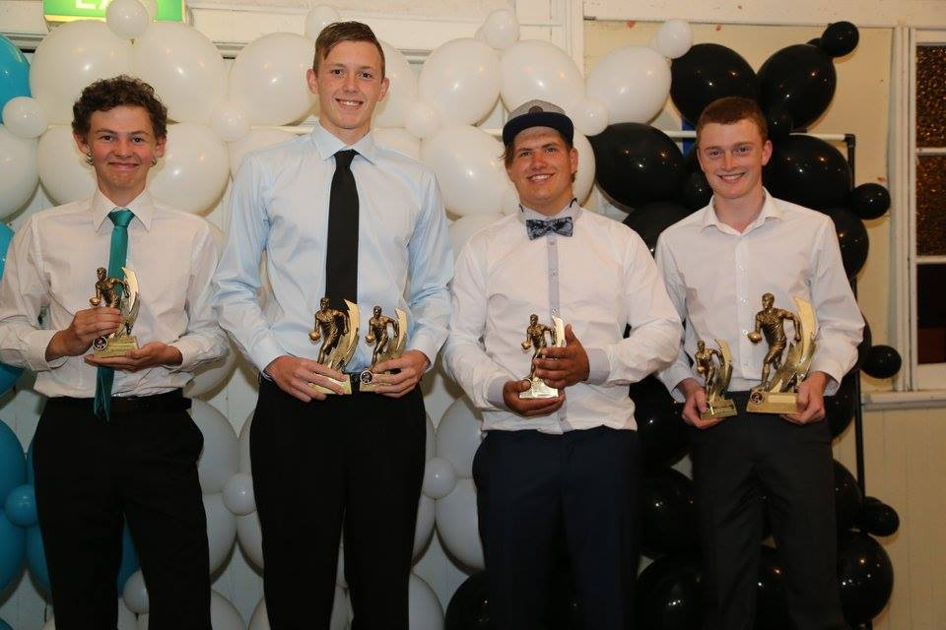
Southern Storm Colts Trophy Winners - (from left) Jake Munnings, Joe Direen, Kyle Russell, Nathan Duggan

Coach Shane Clark presented the Reserve Awards to Tom Slevin (Best & Fairest) and to joint B&F Runners-Up in Darcy Millhouse and Patty Wilcox. Other Reserve winners were Daniel Donato (Most Courageous), Luke Smith (Most Improved) and Chris Brereton took home the Coaches Trophy. On behalf of his Reserve teammates, Luke Smith presented ‘Sticks’ with a framed signed Port jumper in recognition of his fine coaching efforts over the past few years.
Port - Reserve Trophy Winners - (from left) Luke Smith, Darcy Millhouse, Daniel Donato

It was really the ‘Ben Halton Show’ as Brayden Hayes, assisted by 2017 Senior Coach Ben Cato, presented the Senior Awards. ‘Halts’ had a tremendous season and almost needed a semi-trailer to take home his swag of awards, which included the Senior Best & Fairest, Leading Goalkicker, Lyle Graham Most Valuable Player (voted weekly by all Senior players) and Best in Finals Awards. Ben also shared the prestigious Synnott Brothers’ Trophy with Will Ford.
‘Fordy’ was also awarded the Runner-Up B&F and Best Backman Awards, while other Senior trophy winners were Cameron Wilcox (Best Team Player) and Toby Cowen (Greg Gordon Memorial Rising Star Award).
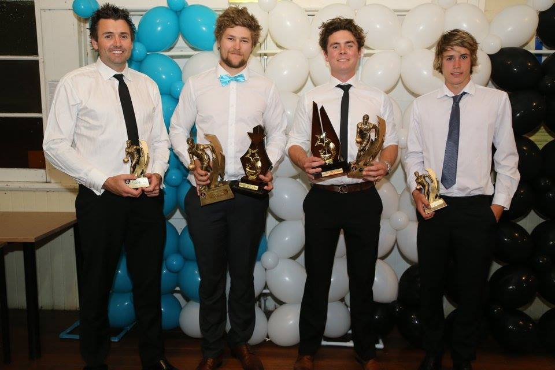
Port - Senior Trophy Winners - (from left) Cameron Wilcox, Ben Halton, Will Ford, Toby Cowen

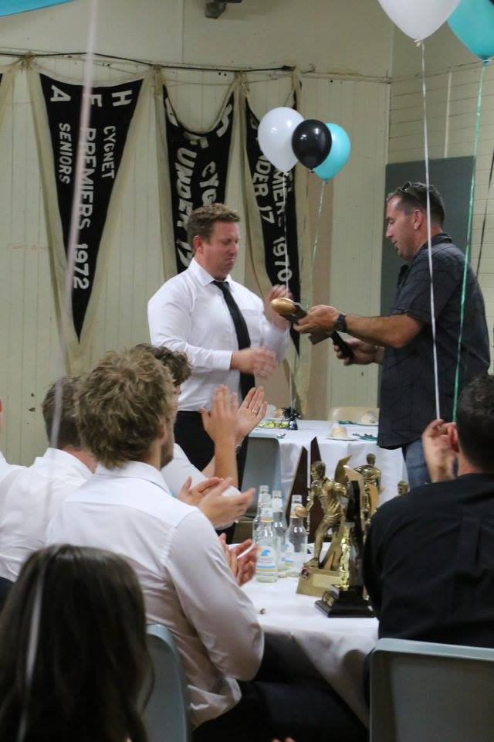
Marcus Synnott was a very deserving winner of the EM ‘Boysie’ Direen Memorial Best Clubman Award. Marcus was instrumental in the project management and building of the new Change Rooms, is a very active Vice-President, a member of the Club’s Recruitment Team, Senior Match Manager and well as taking on numerous other tasks around the Club.

In another worthy acknowledgement, Leigh Shepheard was awarded the Kathryn Hodgman Club Spirit Award in his first year at the Club.
Congratulations to all award winners and a special thank you to all our sponsors and trophy donors for their contribution to our Club over the past season and for making the Awards Night such a success.
ONLY TWO WEEKS TO ROUND ONE
Last Saturday the Port journeyed to Snug Oval to play a practice match against Old Scholars team, Hutchins. New Port Coach, Ben Cato, was pleased with the encouraging hit out and the signs that everyone was taking on board the game plan and using the practice match to learn and grow as a group.
Storm lads, Jackson Gordon and Joe Direen kicked multiple goals while the experienced heads of Sam Dean and Rhys Jennings led the midfield well.
The 2017 SFL Season is not too far away and will kick off on Saturday 8th April, with the Port travelling to Dodges Ferry to take on the Sharks.
The following week, Easter Saturday, we will host our first home game against last year’s Premiers, Claremont before we travel to Lindisfarne the following week (22 April). Certainly a tough draw to start the season, but a great opportunity to see where we sit in relation to the top teams.
The boys have been training hard since November and with good numbers on the track are keen for the season to get underway. The Club will see a number of quality ex-players returning to the Port this season and these will be featured in next week’s Port News.
Matt Whitehouse and Ollie Burke will share the Reserve Coach’s role this season and their considerable playing experience should be invaluable to the Reserves team. Matt Brereton will once again coach the Southern Storm Colts team, and is hoping that the Storm lads can continue their progression and again be a real premiership contender.

