NEWS FROM THE PORT
The ‘Cygnet Community Bank Football Club’ played host to the strong Claremont teams last Saturday in the Club’s first home game for the 2017 season. Conditions were absolutely perfect for football with plenty of sunshine, no breeze and the ground in magnificent condition.
Southern Storm Colts
After leading by over 40 points before losing to Lindisfarne the previous week, the Storm were keen to put in a much better and sustained performance against last year’s Premiers Claremont. In a very tight first quarter, where scoring was difficult, Claremont had a slender one goal lead at the first break. Play opened up in the second quarter with both teams moving the ball quickly but it was the Storm who made the most of their scoring opportunities, kicking five goals to two to lead by 15 points at half-time. The game again tightened up in the third quarter with the Claremont Magpies kicking four goals to three to reduce the Storm’s lead to one goal only at the final change. When Claremont levelled the score after only 30 seconds of play in the final quarter, the game was up for grabs and another exciting finish looked likely. Goal sneak Jake Dance slotted two goals to give the lead back to the Storm before Claremont replied with a goal of their own. Elijah Reardon then stepped up with a couple of goals and the Storm’s lead was out to three goals. The Storm then kicked away with another four goals to Claremont’s one to run out victors by 36 points.
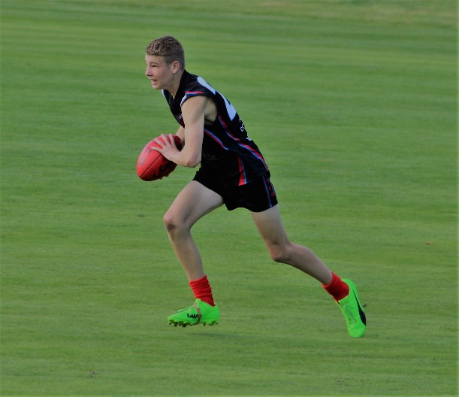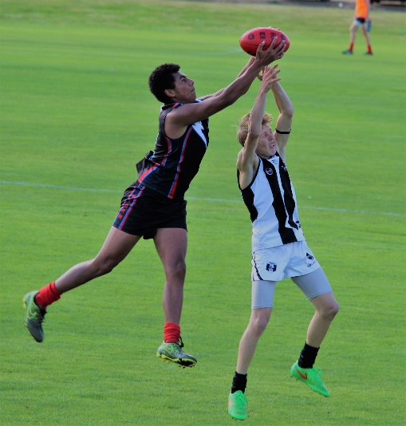
The Storm’s accuracy was exemplary, kicking 11 goals straight after half-time. Better players for the Storm in an excellent team effort were Jake Dance (5 goals), Marcus Coulson (3 goals), Elijah Reardon (2 goals), Jake Munnings (3 goals) and Scott Blacklow. The other Storm goal scorers were Jacob Direen, Campbell Gane and Jack Brereton.
Coach Matt Brereton was very happy with the overall team performance and particularly the way the boys handled their opponent’s pressure and ran the game out strongly.
PORT Reserves
The PORT Reserves knew they had a big challenge in front of them as they fronted last year’s Reserve Premiers, a team that has shown so much depth and excelled over many years. Like the earlier Colt’s game, the first quarter was a real arm wrestle as both sides struggled to gain any clear ascendancy. The Magpies lead by two goals at the first break, but soon started to get their running game going in the second quarter, kicking six goals while keeping the PORT scoreless, and it looked like how far Claremont! After a rallying talk by co-coaches Matt Whitehouse and Ollie Burke, the PORT really took it up to their opposition in the third term, but with their superior fitness and ball movement, the Magpies extended their lead to 13 goals at ¾ time. A further three goals to nil in the final quarter gave the visitor’s a percentage boosting win by 102 points.
The PORT’s better players were Aaron Dance, Tom Slevin, Daniel Donato, Matt Cane, Adam Direen and Marcus Coulson. Ian Coulson, Chris Stockfield and Matt Cane were the PORT’s sole goal kickers.
PORT Seniors
After losing several key players through injury from the previous week, the PORT welcomed Sam Dean, Nathan Duggan, Matthew Coulson and Julian Parker into the Senior side, in what promised to be a true litmus test for the PORT against the reigning Premiers. In perfect conditions, both sides were quickly on the attack and hitting the scoreboard. Kicking to the bottom end, the PORT had the better of the first quarter, with four goals to Claremont’s three to hold a nine point lead at quarter time. Despite having a good percentage of the play in the second, the PORT were unable to penetrate the Magpie’s strong half back line. Claremont’s inaccuracy (two goals seven behinds for the quarter) was keeping the PORT in the game but the Magpies had taken the lead by 10 points at half-time.
With Senior Coach Ben Cato encouraging the PORT boys to stick to the game plan and move the ball quickly to their key forwards, the PORT got back on the scoreboard in the third quarter courtesy of two great snap goals by Ben Halton. However Claremont added four goals of their own to extend their lead to four goals going into the last quarter. Although the PORT were quick to score and after 10 minutes had reduced the margin to 13 points, Claremont were able to hang on to win a very good contest by 16 points.
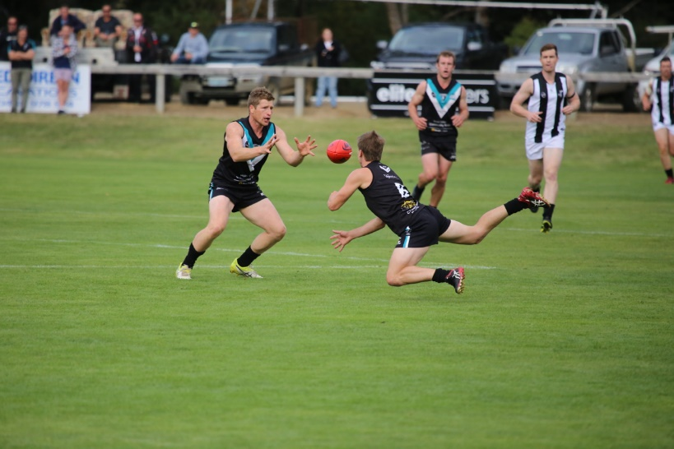
In what was a much improved and promising performance by the PORT, better players were Sam Dean, Will Ford, Ben Halton (who finished with 4 goals), Mitch Direen, Cam Wilcox and Nathan Duggan. Josh Halton booted two goals, with single goals to Ben Cato, Loic Auderset (playing his 100th Club game) and Andrew Palmer.

This week’s games
This week the PORT travels to ANZAC Park to take on last-year’s runners-up, Lindisfarne. The Club encourages everyone to get along to witness what will certainly be another tough challenge, but also a great opportunity to see where the PORT and Southern Storm rank compared to the top teams.
The following week (Sat 29th April) at Cygnet, the PORT will battle it out with archrivals, the Huonville Lions, for the annual Community Bank Shield. The Huon Valley Community Bank is a very generous supporter and sponsor of both clubs.
“Support The PORT in 2017”

