PORT NEWS
TOUGH DAY AT THE OFFICE FOR THE PORT
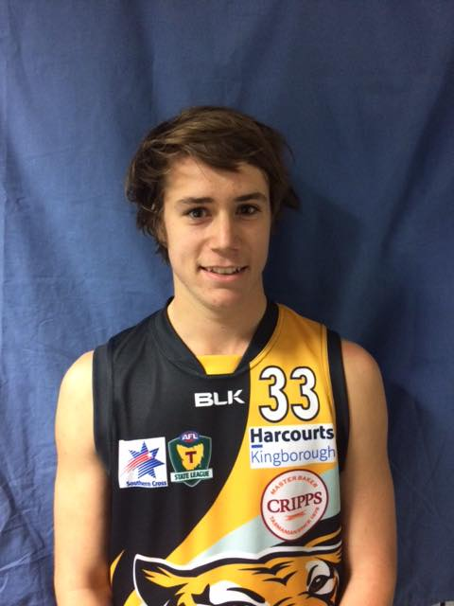
Toby Cowen
Congratulations to ex-Cygnet and Southern Storm lad, Toby Cowen who made his Tas. Statewide League senior debut with the Kingborough Tigers last Saturday. Toby acquitted himself well and was named in the Tiger’s best players. Well done Toby.

Last Saturday the ‘Cygnet Community Bank Football Club’ headed up to Boyer Oval to take on the undefeated ladder-leaders, New Norfolk, whilst on Sunday the PORT Women played the South East Suns at Dodges Ferry.
It was a tough day for the PORT and Southern Storm teams as the Eagles were too slick and classy in all three games making the most of the huge expanses of their home ground.
Southern Storm Colts
In cool but sunny conditions, the Southern Storm Colts got off to a reasonable start but their opponents were quickly on the scoreboard and led by 15 points at quarter time. Despite battling gamely, New Norfolk broke the game open in the second and third quarters, kicking three goals in each quarter to the Storm’s one goal and two goals respectively, and the margin in the Eagles favour had widened to 38 points at the last change.
To the Storm’s credit they never gave up trying but the Eagles were able to kick a further four goals to the Storm’s one in the final quarter to run out comfortable winners by 58 points.
Better players for the Storm were George O’Neill, playing only his second game for the year, Jackson Gordon, Jack Brereton, Jacob Hayers, Peter O’Neill and Will Donato. The Storm’s five goals were kicked by Jake Dance (2), Jordan Lane (2) and Matthew Hayers.
The Storm will need to regroup and be in top form when they face the undefeated Hobart Tigers at Kermandie in their next game (27th May).
PORT Reserves
The PORT Reserves again had difficulties fielding a side due to players promoted to the Senior team and injuries, but welcomed key forward Micheal ‘Pud’ Darcy for his first game of the season.
New Norfolk got off to a quick start with the PORT struggling to keep up with their opponent’s quick ball movement and run off half-back. By half-time the Eagles had kicked 11 goals to the PORT’s three and led by almost nine goals. The PORT put in a much improved effort in the third quarter restricting the Eagles to 3 goals, but the big ground and player fitness were taking its toll and a five goals to nil final quarter saw New Norfolk’s final margin extend to 99 points.
Ben Smith battled hard all day along with Shane Clark, Julian Parker, Matt Cane, Ryan Panton and Chase Connolley. ‘Pud’ kicked two goals with singles to Ian Coulson and Shane Clark.
PORT Seniors
The PORT welcomed back Ben Halton and Brayden Hayes but were without injured ruckman, Gerard Brereton for their clash with the very experienced and skilful New Norfolk.
The PORT defence was under constant pressure from the very first bounce as the Eagles on-ballers got first use of the ball and constantly drove the ball forward to their leading forwards. In a first quarter blitz, the Eagles scored ten goals to the PORT’s two goals and the result was effectively decided. With PORT Coach, Ben Cato encouraging his players to be more accountable and commence their own running game, the PORT put in a much improved second quarter slowing the New Norfolk scoring, but two late goals to the Eagles extended their half-time lead to 13 goals.
New Norfolk continued on with their slick, running game in the second half, making the most of their scoring opportunities, kicking ten goals from twelve scoring shots, and countering every effort by the PORT to reduce the margin, which by the final siren was 116 points.
Marcus Coulson, playing his first senior game for 2017, was excellent up forward, winning many possessions across half forward. Fellow youngster, Joe Direen shouldered the bulk of the ruck work against ex-AFL and Cygnet player, Jason Laycock and acquitted himself well, while backmen, Darcy Millhouse, Nathan Duggan, Paddy O’Neill and Mitchell Direen never gave up trying to stem the relentless New Norfolk scoring tide.
Josh Halton (3 goals) was the only multiple goal scorer, with single goals kicked by Will Ford, Marcus Coulson and Ben Halton.
The loss means that the PORT have slipped further behind fifth-placed Huonville on percentage, with the Lions also having played one less game.
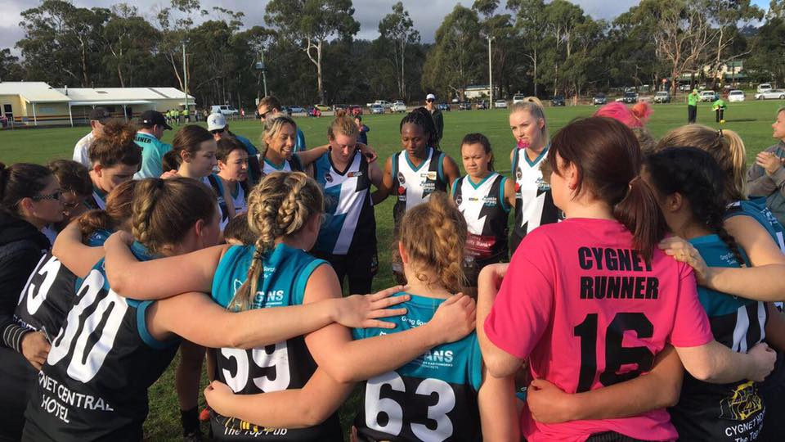
PORT Women
PORT Women listening to their Coach’s instructions
In a Mother’s Day clash last Sunday, the PORT Women travelled to Shark Park to play the unbeaten South East Suns, in what was expected to be a hard fought game against tough opposition.
The first quarter was an even contest, with great ruck work and run through the middle from Nelly Iduteyiteka, backed up by Demi Game and Caitlin Phillips, who converted a fine set shot at goal. Both teams were evenly contested for possessions, with the Suns taking a slight advantage at the first break.

The second quarter saw PORT again put up a solid fight and with some position changes, Heidi Pettit entered the forward line, kicking a great running shot at goal. Grace Lovell tried hard on the backline, with solid backup from Jade Harvie, limiting the opposition’s scoring chances. The Suns led by 15 points at the half time break.

In the third quarter, the PORT continued to push hard against their strong opponents. Georgia Baldwin and Samantha Grimsey provided speed through the midfield, with our back line working overtime to limit the tireless Suns who kicked on, taking a satisfying lead into the final break.

In the last term, PORT strived to pull back the Suns lead, Tash Cormie, after an earlier injury, dug deep to fight the game out, but the Suns were able to maintain their consistency, keeping PORT goalless and running away with the win 94 to 14.

This was a tough game for the PORT, with the scoreline not reflecting how close the contest was against a great South East Suns team. Special mention to PORT’s first Aunt/Niece duo to take the field together, Coach Tricia Phillips and niece Caitlin and congratulations to the rookies who faced the toughest of opposition for their first game. The Club thanks the Tiger’s ladies and all the volunteers who help and support the PORT Women each week.

This week’s Games
There are no club games this Saturday (20th May) as the NWFL v SFL Representative Match will be played at Ulverstone. At the time of writing this report, the final squad had not been named, but hopefully the PORT will have a couple of representatives playing.
For your footy fix this weekend, why not get along to watch the PORT Women play Claremont at the Kingborough Twin Ovals this Sunday (21st May), with the game commencing at 1.40pm.
The following weekend the PORT Women will play the Blues Women at Lindisfarne on Friday night (26th May) while the PORT and Storm men’s teams play Hobart at Kermandie on Saturday (27th May).

“Support The PORT in 2017”

