PORT CLUB NEWS – 17 June 2017
‘GREAT DAY OF FOOTY AT SNUG PARK’
Perfect weather, perfect ground conditions and a large crowd was the order of the day last Saturday as the Cygnet Community Bank Football Club hosted Sorell at Channel’s Snug Park. The Port Women also welcomed the South East Suns for their return match.
Taking the game to Channel is a Club initiative to acknowledge the contribution of a number of ex-Channel players now playing with the Port and allow local Channel residents to again watch footy on their ‘home turf’.
Southern Storm Colts
The Storm lads met fierce opposition from the first bounce as their Sorell Eagles opponents, seeking their first win for season 2017, showed great purpose and desperation as they took the challenge right up to the Storm. After a first quarter which saw the Storm have eight scoring shots to two, its inaccuracy meant that the Storm only led by one goal at the first break. Sorell had the better of a low scoring second quarter but the inaccuracy ‘bug’ also bit them as they scored one goal only from their seven scoring shots, but that was enough for the Eagles to take a 5 point lead at half-time.
The second half was more of the same as the game went goal for goal, with neither team able to gain a clear advantage over the other. The Storm held a slender one point lead at three quarter time and an exciting last quarter was on the cards. The Eagles kicked the first goal of the last quarter to regain the lead and it looked like they might get the victory. However, a Storm goal late in the quarter put them one point up and they managed to hold that margin until the final siren.
Better players were Jackson Gordon (2 goals), Liam O’Neill, Jacob Hayers (3 goals), Max Cowen, Jack O’Neill and Jack Brereton. James Zeitzen kicked the remaining goal.
Next week the Storm will be at home to Lindisfarne and will need to play their best team football if they are to secure a victory and move into third place on the Colts ladder.
Port Reserves
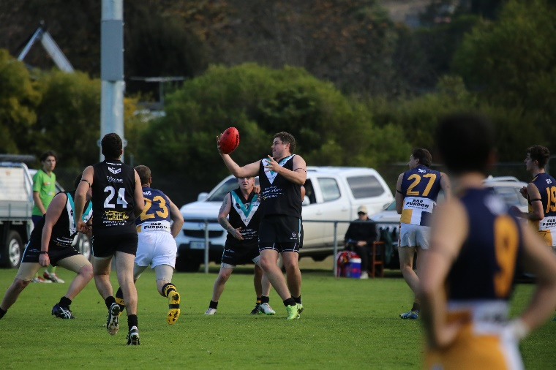
The Port Reserves came out all guns blazing, winning the centre clearances and getting the ball quickly down to their two key forwards in Chris Stockfeld and Nick Townsend, who were marking strongly and converting. The flood gates really opened for the Port in the second quarter with a further seven goals to none and the Port held an eleven goal lead at half-time.
Nick Townsend pulls in the mark
The Eagles opened their goal account in the third term with two goals but with a further five goals of their own the Port’s lead was 15 goals at three quarter time. The Port continued to score freely in the final quarter with the final margin extending to over 100 points and the Port had secured their second win for the season.
Leigh Savage and Matt Cane won many of the centre clearances, Ryan Panton and Brad Sculthorpe battled well all day, while Chris Stockfeld and Nick Townsend with 7 goals and 5 goals respectively finished off their team mate’s good work. Matt Coulson kicked 2 goals, with Ian Coulson, Shane Clark, Dwain Warn, Elliott Ross and Ben Smith the other goal scorers in a morale boosting win for the Port Reserves.
Port Women
In Round 7, the Port Women faced the highly competitive South East Suns. From the first bounce, the Suns went out hard and were able to control the pace of the game. Marlin Letiko and Caitlyn Phillips worked hard to create turn overs, but the Suns were able to convert all four goals of the term to have a 29 point lead at quarter time. In the second term, helped on by some great defensive pressure from Holly Upston and the ever reliant Kara Geeves looking for the ball, the Port were able to hold the Suns to just two goals for the quarter.
Returning from the main break, into the third quarter, the Port managed to maintain more possession of the ball, with the help of Demi Gane out of the centre and Chantel Clark on the wing. The Suns however had all the answers and were able to kick another 3 majors of their own, taking a 62 point lead into the final term.
With Letiko in the ruck, combining with the run of Geeves, the Port were able to push the ball forward more in the final quarter and play on with a never give up spirit. Unfortunately the Port Captain, Caito (Phillips), was injured and stretchered from the ground and the final minutes of the game were stopped as a mark of respect.
The Club and players thank all the Coaching Staff and Trainers who helped throughout the day and particularly all of those who took great care of Caito.
Port Seniors
In a moving moment, the Sorell and Cygnet senior players, Club officials and umpires lined up for a minute’s silence prior to the game as a mark of respect to Nigel Glanville, a past player of both Clubs, who sadly past away during the week.
After excellent form with the Storm Colts, the Port welcomed Jake Dance for his first senior game, but unfortunately, Tom Nicholls, who had missed several weeks with a serious hamstring injury, aggravated a calf muscle during the warm-up and was a late withdrawal.
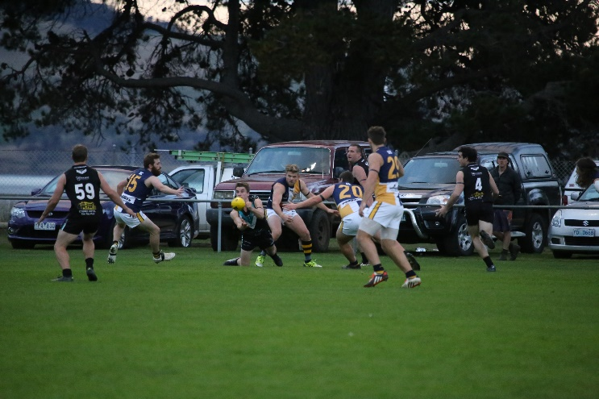
The game did not start as expected for the Port, with the Eagles taking an early lead and the Port looking a bit rusty following consecutive bye rounds and having played only one game in the past month. Sorell held the lead mid-way through the second quarter and then, almost coinciding with the Snug Park ground lights being turned on, the Port’s running and free-scoring game kicked in. Three late Port goals for the quarter had them up by that margin at half-time.
Rhys Jennings gets the ball out
With the Halton brothers and Will Ford providing excellent targets up forward, it was mostly one-way traffic after half-time as the Port kicked away with a further twelve goals to four to run out convincing winners by 78 points.
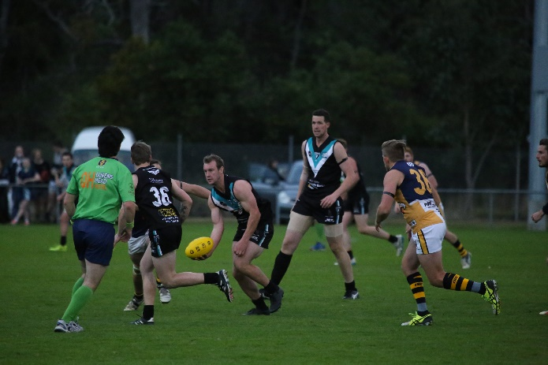
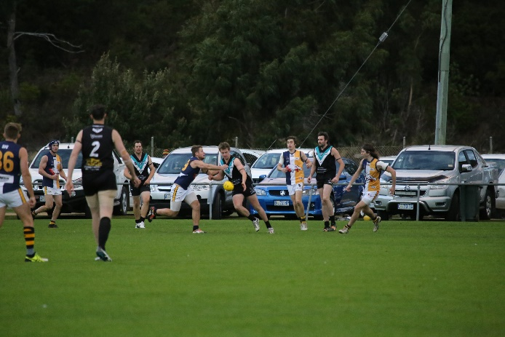
The Port midfield of Sam Dean, Brayden Hayes, Andrew Palmer and Rhys Jennings were excellent contributors, winning much of the ball and centre clearances, and creating numerous scoring opportunities for Josh (7 goals) and Ben Halton (6 goals) and Will Ford (4 goals).
Corey Polley continued on from his good form at Kermandie, Jake Dance kicked his first senior goal in the final quarter while Rhys Jennings and Aaron Dance also hit the scoreboard.
Sam Dean handballs to a team mate

Corey Polley clears the ball

This Week’s Games
This Saturday the Port Seniors and Reserves will host the Dodges Ferry Sharks at Cygnet, as the second round of SFL roster matches gets underway. The Sharks were convincing winners over the Port in round one and the Port will be keen to reverse the result and consolidate fifth spot on the ladder. As Dodges Ferry do not have a Colts team this season, the Southern Storm will host third-placed Lindisfarne, also at Cygnet.
The Port Women have the bye this weekend and their next game is against the Claremont Magpies at Cygnet on Sunday 2nd July, with the game commencing at 3pm. The Club would love to see larger crowds along to support and encourage our local Women’s football team.
Port’s Comedy Night
The Port’s Comedy Night, featuring the ‘Legends of Review’ with several local comedians including the very funny John X, will be held this Saturday following the Dodges Ferry game. This promises to be a fantastic night of fun and side-splitting laughter, so make sure you get your tickets.
The night will be proudly sponsored by one of our Corporate Sponsors, Southern Smash Repairs.

Go The PORT!

