PORT CLUB NEWS – 24 June 2017
Port gets good win over the Sharks
In cold and wintery conditions last Saturday, the Cygnet ‘Community Bank’ Football Club played host to the Dodges Ferry Sharks while the Southern Storm Colts took on third-placed Lindisfarne.
Southern Storm Colts
The Storm were facing the Lindisfarne Two Blues for the third time this season and were keen to atone for their two earlier losses and keep in contact with the top two teams. The Storm got off to a great start and had most of the play in their forward 50 zone but were missing some easy shots. They led by 22 points at quarter time but for their inaccuracy could have been further in front. The game really opened up for the Storm in the second quarter with Marcus Coulson, Jake Dance and George O’Neill providing excellent targets up forward and finishing off the good work of their on-ball team mates. Five goals to one in the Storm’s favour gave them a handy 8 goal lead at half-time.
The second half was more of the same with the Storm kicking four and five goals in each quarter while restricting their Two Blues opponents to a single goal for the half. The lead steadily increased to a final percentage-boosting margin of 109 points.
Better players in an excellent team effort were Marcus Coulson (7 goals), George O’Neill (3 goals), Sean Burgess, Liam O’Neill, Scott Blacklow and Jacob Hayers. Jake Dance continued his fine form with 5 goals, Jack Brereton kicked 2, with singles to Campbell Gane and Sean Burgess.
The Storm have now displaced Lindisfarne and moved into third place on the ladder, but will need to continue their good team play next week against Claremont to consolidate their spot.
Port Reserves
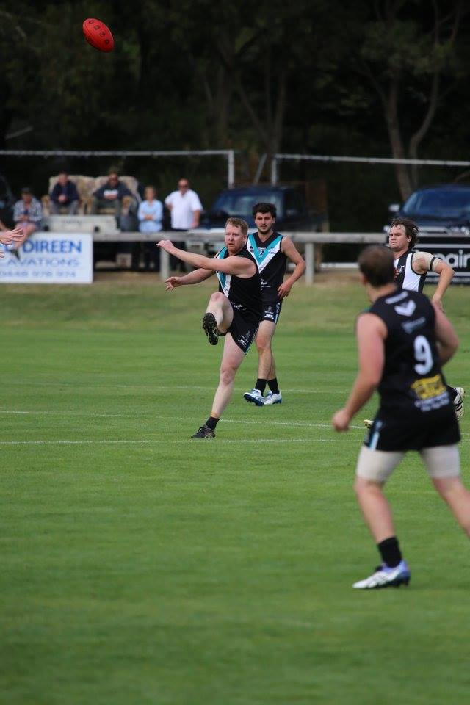
The Port Reserves were missing a few of their players from the previous week as they lined up against fourth-placed Dodges Ferry. They were led onto the ground by club stalwart, Matt Cane, who was lining up for his 200th club game for the Port. Matt has been a great and much-admired servant of the Cygnet FC for the past 14 seasons, always giving his best and sticking by the club during its lean years.
It was an even contest in the first quarter as both teams struggled to hit the scoreboard. A low scoring two goal to one quarter had the Sharks up by the single goal at the first break. The Port were outplayed by their opponents in the second quarter with Dodges extending their lead to 3 goals at half-time.
Matt Cane gets his kick away against Claremont earlier this season
With Coaches Matty Whitehouse and Ollie Burke encouraging their players to really take the contest up to the Sharks, the Port’s third quarter was a more keenly contested effort. Although down by 4 goals at three quarter time, the Port were still in the game. However it was not to be as the Sharks kicked away in the last quarter, extending their lead to 38 points at the final siren.
Julian Parker, Shane Clark, Lucas Pel and Jack Brett were good players all day and worked off the good ruckwork and tackling pressure of Chris Brereton and Pat Ford. The Port’s five goals were shared by Jack Brett, Julian Parker, Dean Dawe, Chris Stockfeld and Matthew Coulson.
The challenge for the Reserve boys is to get on the training track this week and really prepare well for next week’s game against Claremont.
Port Seniors
When they first met in round one at Shark Park, the home team proved too strong for the Port and ran away with the game to win by nearly 50 points. Playing on their home ground, the Port were keen to reverse the result and draw level with their opponents on the ladder and consolidate their position within the top five.
The Port were winning their share of the centre breaks early and were quickly on the scoreboard, with Josh Halton dominating the Shark backs, kicking four goals for the quarter. However, a couple of late goals to the Sharks reduced the Port lead to 19 points at quarter time. Dodges had the better of the second term, reducing the margin to five points late in the quarter, before a snap goal to Elijah Reardon took the Port lead out to 11 points at half-time, and it was game on.
An early goal to the Port in the third ‘premiership’ quarter gave them the momentum and with a further three goals to one for the quarter, the Port were able to extend their lead to 28 points at the final change. The last quarter went goal for goal with the Port able to answer every Shark challenge and at the final siren the margin was 22 points in the Port’s favour. Overall it was a very good result and an even team effort by the Port.
Sam Dean was again in great form, winning numerous contested balls and clearances, Mitch Direen was excellent with his hard running off half-back while Josh Halton took several fine marks and finished with seven goals. Young Joe Direen battled well in the ruck and around the ground, Pat Verrell (2 goals) was a good contributor all day as was another young player, Jackson Gordon.
Ben Halton (3), Brayden Hayes (3) and Elijah Reardon were the other goal scorers.
This week’s games
This Saturday the Port and Southern Storm travel to Abbotsfield Park and must be right on their game if they are to challenge the strong Claremont teams on their home turf.
The Port Women will also take on the Claremont Magpies, but their game will be at Cygnet on Sunday 2nd July, with the game commencing at 3pm. The Club would love to see a large crowd along to the Port on Sunday to support and encourage our local Women’s football team.
Port Comedy Night
The ‘Legends of Review’ Comedy function held last Saturday after the Dodges Ferry game was a great success with much laughter and frivolity. Thanks are extended to the wonderful Social Committee of Jayne, Marita, Katey, Brigid and the other girls for organising this fun social event.
Past Players Function – Saturday 22nd July
The annual Cygnet FC Past Players and Officials Function will be held from 11am on Saturday 22nd July, with Collingwood Premiership Captain, Tony Shaw, the guest speaker. Tickets are now available for $60 and are selling fast. For more details see the Club website (cygnetfc.com.au) or Facebook page (Port Cygnet Football Club).
Go The PORT

