PORT TOPPLES CLAREMONT
Last weekend the Cygnet ‘Community Bank’ Football Club took on the Claremont Magpies in both the men’s and women’s competitions, and in a great result came away with three wins from the four games.
Southern Storm Colts
It was a frosty start to the day at Abbotsfield Park as Harry Ashlin, Connor Soward and Innocent Mahlangu were welcomed for their first games for the Storm. Coach Matt Brereton had the Storm lads well primed up for a big game against their Magpie opponents and this immediately translated onto the ground when the Storm kicking seven goals in the first term to open up a handy six goal lead at quarter time. However, the second quarter was almost a reversal of the first, with the competitive Claremont hitting back with four goals to the Storm’s one and the margin was down to 19 points at half-time.
The home team continued their fine play in third quarter, kicking a further four goals while restricting the Storm to one behind and the Magpies had now taken the lead by 8 points and another nail-biting finish between these two sides was looking highly likely.
Whatever Coach Matt said to his troops at three quarter time certainly worked, as the Storm ran extremely hard and completely outplayed their opponents in the final quarter, kicking seven goals to one behind to run out comfortable winners by 35 points. Certainly a very good result, however the Storm will need to address its consistency over four quarters as it can’t afford to switch off for one or two quarters, particularly when playing against the top sides.
On-ballers Sean Burgess, Will Donato and Liam O’Neill were in everything, winning the hard ball and driving it forward at every opportunity. Scott Blacklow, Peter O’Neill and debutant Connor Soward (4 goals) were also fine contributors in an even team performance.
Jake Dance finished with 3 goals, Sean Burgess (2) while Max Cowen, Kyle Russell, first-gamer Harry Ashlin, Jacob Hayers, Liam O’Neill and Will Donato each kicked a goal.
PORT Reserves
A severe shortage of available players meant that Matt and Ollie had to call on a number of past players as well as several Storm lads to make up the numbers for the Reserve game.
On the other hand, second-placed Claremont showed their depth of player talent as they moved the ball quickly and cleanly, utilising the wide expanses of Abbotsfield Park to perfection. The scoreboard pressure constantly mounted on the Port, as the Magpies kicked nine goals in both the first and second quarters while the Port could only score three behinds for the first half.
The Port really worked hard in the third term, restricting their opponents to three goals while kicking their first goal for the game. However, this effort took its toll as the Magpies racked up another nine goals to one in the final quarter to run out victors by 179 points. The Club greatly appreciates and acknowledges those ‘retired’ players and Storm lads who pulled on the boots so that the game would not be forfeited.
Better Port players were Ben Smith, Shane Clark, Paul Cowen, Daniel Webster, Chris Stockfeld and Jack Brett. Young Storm player, Jake Dance, playing alongside his father Phil and Uncle Rodney for the first time, kicked one of only two goals scored by the Port.
The Club passes on its best wishes to Chris ‘Big Red’ Brereton for a speedy recovery from his kidney injury received during the second quarter of Saturday’s game.
PORT Seniors
Weather and ground conditions were perfect for the start of the Senior game which presented another big challenge for the Port to win against a higher-placed team. The game opened at a frenetic pace, with both teams getting plenty of the ball, but the Magpie’s defensive pressure and Port’s inaccuracy kicking towards the Clubroom end were keeping scores close. Despite the Port having eight scoring shots to three for the quarter, scores were level at 13 points apiece at the first break.
The early part of the second quarter went the same way with neither side able to gain the ascendency. The moves of Gerard Brereton into the ruck, Ben Halton onto the ball with Sam Dean and Joe Direen to the forward line paid immediate benefits with Joe kicking a much needed goal for the Port who took a two goal lead into the half-time break.
The third quarter was a tight affair with the Port scoring two goals but importantly the Port’s pressure at the contests restricted the Magpies to only one behind for the quarter, and the Port’s lead had extended to 28 points at the final break.
The game really opened up in the final quarter as the Port’s continual pressure caused turnovers and in a fine team performance the Port skipped away with six goals to two to run out winners by 47 points.
Ben Halton lead the way with fellow on-ballers Andrew Palmer and Sam Dean, Brayden Hayes (4 goals 7 behinds) was running his opponents ragged while Cam Wilcox controlled the last line of defence. Josh Halton kicked six goals, continuing his fine run of form which has seen him kick 18 goals in the past three games and 39 goals for the season.
Others to hit the scoreboard were Joe Direen (2), Ben Halton and Ben Cato.
The win was probably the Port’s best four quarter performance for the season, with the team’s ability to stick to the game plan most pleasing as was the pressure applied to the Claremont ball carriers which created numerous turnovers and scoring opportunities for the Port.
PORT Women
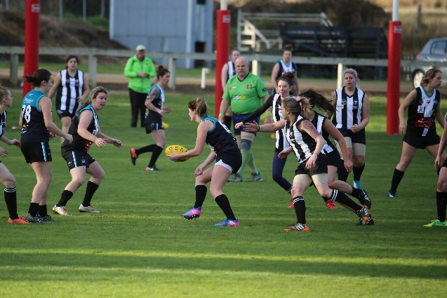
The Port Women hosted Claremont in their final home game at Cygnet for the season last Sunday. Knowing the Magpies would come out a more determined and skilled team then earlier in the season, a good game was expected in beautiful playing conditions. Demi Gane impressed in the ruck from early in the game, creating many opportunities for the Port to push the ball forward. Kara Geeves’ input was stamped from the first bounce and the home side managed to take a slight break at quarter time, impacted by some inaccurate shots on goal.
Port continued to maintain the majority of possession in the second. Caitlin Phillips' work rate lifted through the midfield and Keren Scotney pushed hard in the backline to control the Pies' attack and keep the ball out. Port continued to hold the lead at the main break. With the first half over and the sun fading, the match continued to be a great contest, with turn overs both ways and the two Clubs giving their all still. Brittany Woolley impressed in her first game for the Port, creating great clearance and run from the centre to help the Port maintain their lead going into the final term.
Demi Gane to Kara Geeves
In the last quarter, the Port managed to maintain intensity and hold onto their lead, with newcomer Gemma Terry playing a strong role in the second half of the game and helping the Port to hold onto a 30 point win over their Magpie opponents. Well done to the opposition on their improvement and for scoring their first goals of the season.
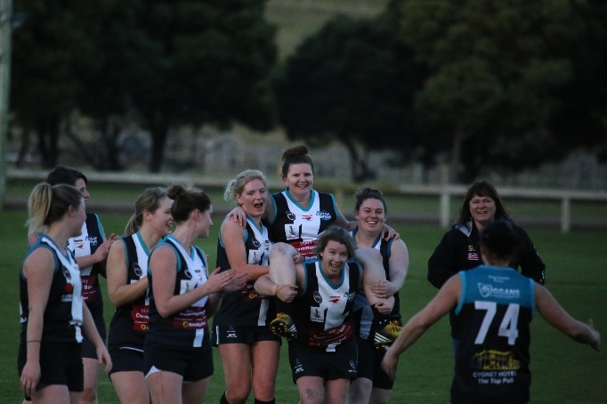
A huge congratulations to Renee Schuettpelz on her 50th AFLW game, a massive achievement for Women's football in our region and topping it off with a goal in the dying seconds of the game. Special mentions to rookie, Rene Reichart on her first ever game of footy and to Brit, Meg and Gemma on playing their first games in the Port jumper.
50th gamer Renee Schuettpelz

Better players were Gane, Woolley, Terry and Scotney. Captain Caitlin Phillips, alongside newly elected vice-Captain Kara Geeves, kicked 2 majors each and were again among the Port’s best. With a final scoreline of 5 goals 20 behinds, kicking practise may be the order for Port’s training this week!
This week’s games
This week the Port plays host to second-placed Lindisfarne at Cygnet, which will be another tough challenge for the Port and Storm Men’s teams. The Port Women will play the Blues at Anzac Park, Lindisfarne on Sunday (9th) with the first bounce at 12.15pm.
Don’t forget the ‘Mechanical Bull and Country Dress-up Night’ after the Lindisfarne game this Saturday, commencing at 7.30pm, with music from 9.30pm. Free entry and a gold coin donation per bull ride. Get along for what is always a fun night.
Go the PORT!!!!

