PORT Club Notes – 15 & 16 July 2017
Battle of the Huon Replay
Last Saturday the Cygnet ‘Community Bank’ Football Club journeyed along the Channel Highway to continue their decades-old ‘Battle of the Huon’ rivalry with the Huonville Lions, and came away with mixed results. On Sunday the Port Women were at New Town Oval for a contest against the Hobart Demons Women.
Southern Storm Colts
The Lions were quickly out of the blocks in the first quarter and in a low scoring game took a seven point lead into the quarter time break. The second quarter saw the Storm play a more committed brand of football kicking four goals to the Lion’s one goal to take a 17 point lead into the half time break.
In the third quarter the Storm were able to score three goals while keeping their opponents goalless and had extended their lead to 6 goals at three quarter time. The Storm boys finished off with a solid last quarter to run out comfortable winners by 43 points. Again the Colts would like to thank the five Under 16 boys who filled in, with all having really good games.
Better players on the day were Jake Dance, who also chipped in with 3 goals, Peter O’Neill had a good game in the centre and young Josh Coad from the Under 16s showed he will be a good player in the future. Campbell Gane made the most of his move forward to kick 2 goals and Kyle Russell was again solid across the half backline using his strength to win plenty of the footy. Jacob Hayers also had a good game providing plenty of run out of the backline. Other goal scorers were Jack Brereton (2) with singles to Elijah Reardon, Jake Munnings and Sean Burgess.
Port Reserves
The Port welcomed back Sam ‘Cookie’ Pritchard for his first game back at the Port in a few years. It was also great to have Chris ‘Big Red’ Brereton back amongst the boys and donning the runner’s top, after his recent kidney injury.
In what would never be classed a pretty game of football, both teams battled hard all day to try and gain some ascendency over their opponents. In a low scoring quarter the home team took a 5 point lead at quarter time. The Lion’s superior accuracy was helping their scoring and despite both teams having eight scoring shots each for the first half, the Lions lead had extended to 10 points at the long break.
With both Matt and Ollie having to get ready for their senior games, the two Phils (Dance and Smith) took over the coaching duties in the second half with Shane Clark assisting in the huddles. The game was effectively won in the third quarter with the Lions booting three goals whilst the Port did not trouble the scorers, with the margin now five goals with a quarter to play. To the Port’s credit they never gave up and outscored the Lions in the last quarter, but it was a case of too little too late and the final margin was 24 points in Huonville’s favour.
Although having a good side on the park, the Port never seemed able to gain any momentum and skill errors and decision making let them down. It was a disappointing result after the big win against the Lions last time around and especially after putting up a great four quarter effort the previous week against Lindisfarne.
Sam Pritchard got into the game early with some good marks and passages of play while Matt Coulson, Grant Clark, Daniel Webster, Ben Smith, Shane Clark and Matty Cane all put in serviceable games for the Port. Chris Stockfeld booted 3 goals while Ben Smith and Matt Coulson kicked one each.
Port Seniors
After a week of great anticipation and build up to this big game and with a big focus on a quick start, the Port managed to get off to such a start, winning the stoppages and having the first scoring opportunities. Brayden Hayes was looking lively at half forward and managed to light the game up with a couple of sharp first quarter goals. Although having the majority of play, it wasn't until the last five minutes of the quarter that the Port managed to kick a couple of quick goals that gave them a 19 point lead which their efforts rightly deserved.

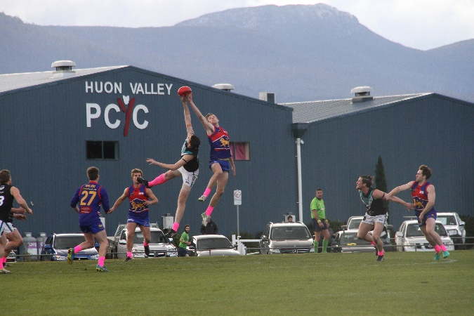
The second quarter was a tough torrid affair, with the Lions responding and getting on top around the midfield. The Port battled hard and defended resiliently, which managed to limit the damage but the Port’s lead was down to 10 points going into the half time break.

Half time allowed the Port to refocus and make some adjustments through the midfield. The first ten minutes of the third quarter would be crucial and Coach Ben Cato urged great intent from the first centre bounce and better ball use to the Port’s key forwards. The Port managed to kick multiple goals to dominate the quarter extending their lead to 32 points and setting the game up for a great win. Josh Halton was dominate in the forward half, taking his opportunities in front of goal an important feature.

The last quarter wasn't a pretty affair with both side suffering from the tough game and despite tiring legs and poor ball use, the Port fought out the game for a pleasing 30 point win against their local rivals.

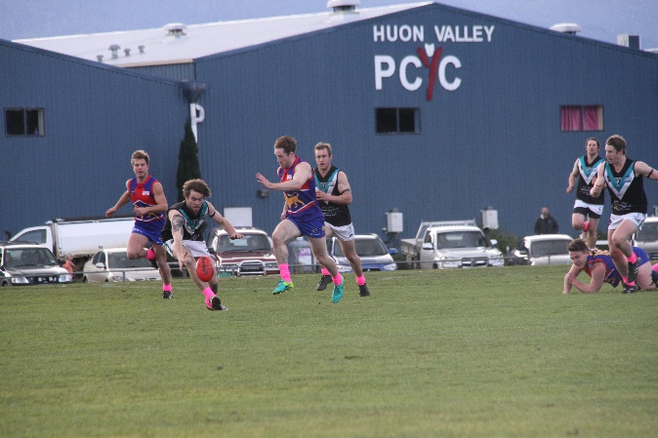
Rhys Jennings and Andrew Palmer were dominate through the midfield while Brayden Hayes (4 goals) and Josh Halton (6 goals) were lively up forward. Will Ford held the backline together taking some crucial intercept marks and Aaron Dance, Pat Verrell and Jackson Gordon all played key roles in the Port’s victory. Ben Cato (2), Matt Turnbull and Rhys Jennings were the other goals scorers.

Port Women
In Round 11, the Port Women were in New Town to take on the in form North Hobart Demons on a chilly Sunday meeting. The first quarter saw a great contest between the teams and with only two rotations on the bench for the day, some hard work was ahead for the Port. Gemma Terry made an immediate impact on the game, seemingly in every midfield contest and the Port were able to put two majors on the board and trail by just 7 points at quarter time.
The second term, however, proved costly toward the final score line as the Port were kept goalless. Demi Gane worked hard in the ruck, but the Port were unable to push the ball forward deep enough, enabling the Demons to turn the ball over and score majors on three more occasions, pushing them to a 28 point lead at the main break.
In the third quarter, the Port came out applying more pressure on the Demons. Caitlin Phillips worked tirelessly all over the ground creating more opportunities for the Port who in turn held the Demons goalless for the quarter, aided by some great defensive pressure from Tonika Hudson, wearing Port colours for the first time.
In the final stretch, the Port women continued to limit the Demon’s scoring chances with some fierce tackling and pressure. Chantel Clark was a good player and battled hard all day, Heidi Pettit finished off a great game on the forward line and the Port Women went down by a respectable 35 points. Another great result and team effort from everyone and a significant reduction in the margin from their previous encounter with the Demons.

Next week
This Saturday will be a huge day both on and off the field at the Port, as the Cygnet Football Club’s Past Players function will be held from 11am, with ex-Collingwood Premiership Captain, Tony Shaw the guest speaker.
On the field the Port and Storm teams will host the Brighton Robins in what are always tough contests, with no quarter given by either side.
The Port Women have the bye round this weekend and the chance to rest up after what has been several weeks of tough games. Their next game will be against the South East Suns in two weeks, on Sunday (6th August).
Live Music (29th July)
The following Saturday (29th July), after the Port’s home game against the undefeated New Norfolk, well-known local band ‘Odyssey’ will be playing live in the Clubrooms @ 8.30 to 11.30pm.

