PORT CLUB NOTES – 19 August 2017
THREE PORT TEAMS TO PLAY FINALS THIS WEEK
The Cygnet ‘Community Bank’ Football Club will play host to Dodges Ferry in the SFL Senior Elimination Final this Saturday while the Southern Storm Colts will take on New Norfolk in the Qualifying Final, also at Cygnet.
The Port Women will play in the First Semi-Final against the Hobart Demons at Cygnet on Saturday, with the first bounce at 9.10am.
Last week’s games
Southern Storm Colts
The Storm, looking to get back on the winner’s list after recent tough losses against the top two teams in Hobart and New Norfolk, started brightly, kicking two goals to nil with the strong breeze to the bottom end in the first quarter, while keeping the Sorell Eagles goalless. With injuries to Jack Brereton, Jack O’Neill and Sean Burgess, the Storm were down to 15 men mid-way through the second quarter, which meant no interchange rotations for the remainder of the game.
The Eagles made better use of their wind advantage, booting four goals in the second quarter but the Storm managed two of their own and scores were locked at 28 points apiece at half-time.
Sorell kicked the only goal of the third quarter and held an eight point lead at the final break, but were coming home with the wind in the final quarter. Despite players tiring, the Storm were defending gamely against the Eagle’s many forward thrusts, but in the end the home team were too strong, kicking three goals to nil to run out comfortable winners by five goals.
Better players for the Storm were Campbell Gane, Kyle Russell, Liam O’Neill, Hallam Blacklow, Peter O’Neill and Jake Dance (2 goals). Elijah Reardon and Liam O’Neill were the Storm’s other goal scorers.
The Storm lads must now regroup and get behind each other if they are to repeat their round 8 victory over second-placed New Norfolk in this week’s Qualifying Final.
Port Reserves
The Port Reserves, strengthened by the return of several players were keen to get a fourth win in their final game of the season. The Port opened the game strongly kicking with the breeze, and the on-ballers were getting good service from Paddy Ford who was winning the ruck contests. A four goal to one quarter had the Port up by 21 points at the first break. The second term saw the Port’s defence get on top, restricting the Eagles to one goal with the breeze, while the Port managed one of their own and the margin was still 20 points at the long break.
The third quarter was an even affair as the home team defended grimly and it was their turn to restrict the Port to one goal with the wind, from five scoring shots. The Port’s lead was out to four goals, but was that a large enough lead given Sorell had the aid of the strong wind in the final term. A couple of early goals to Sorell and the game really tightened up. The Port managed to score a goal against the breeze but the Eagles quickly responded and the difference was down to a goal. However, a late goal to the Port sealed the result and a hard-earned victory for the Port by 13 points.
Jeremy O’Neill showed his experience winning many of the contested possessions, Brad Sculthorpe was strong in defence, while Sam Pritchard, Grant Clark, Lucas Pel and Chris Stockfeld (3 goals) were other strong performers in a very good team performance. Other goal kickers were Daniel Webster, Jeremy O’Neill, Elliott Ross, Lucus Pel and Jack Brett.
The result was a fitting end to the season and just reward for Coaches, Matt Whitehouse and Ollie Burke who have struggled for player numbers and team consistency all season.

Port Seniors
A fourth place finish and a home final were on the line for the Port Seniors, who welcomed back nine players from injury and unavailability for their game against Sorell. The Port jumped out of the blocks with returnees Mitch Direen, Andrew Palmer and Braydon Hayes in everything. Sam Dean was again dominant in winning the centre clearances and the Halton brothers, Ben and Josh, were looking menacing up forward, kicking five goals between them for the quarter. Only inaccuracy marred an almost perfect quarter of football, with the Port scoring 8 goals 7 behinds to nil to lead by 55 points at quarter time. The Port defence, lead well by Coach, Ben Cato, held firm in the second quarter, allowing the home team only two goals with the strong breeze. Meanwhile the Port forwards were finally hitting the target, kicking seven goals two behinds to extend their lead to 85 points at the long break.
It was more of the same in the third quarter as the Port piled on seven goals to one, mainly through Ben Halton whose marking and ground play was causing huge headaches for the Eagle defence. The Port’s three quarter time lead was over 20 goals. To their credit the Sorell boys never gave up, outscoring the Port three goals to two in the final quarter. The final margin was 115 points in the Port’s favour.
The big plus for the Port was the successful return of several key players from injury, with all getting good game time and importantly coming through the game unscathed.
Ben Halton was superb all day and finished with 12 goals, while Sam Dean and Andrew Palmer knocked up winning the hard ball and constantly drove the ball forward. The back line led by Will Ford and Ben Cato was strong all day, with Nathan Duggan and Kane Nielsen both putting in fine performances.
Josh Halton kicked four goals to take his season tally to 60 goals, a great effort, Andrew Palmer and Brayden Hayes chipped in with two goals each, while single goals were scored by Will Ford, Ben Cato, Joe Direen and Paddy O’Neill.
Port Women
In the final round of the Women's roster, Port were host to the second placed Lindisfarne Blues. With weather conditions the complete opposite to the previous week’s blustery game, it was a beautiful Sunday afternoon at the Kingborough Twin Ovals.
Lindisfarne, who have been a strong team throughout the season and very much a premiership contender, had the game locked in from the first bounce. To the Port’s credit, although again low on numbers were forced to run tirelessly throughout the game, with little rest. Taylah Darwin and Jessie Burnett made their debut for the Port Women's team, stepping up from the junior ranks and giving it their all. Promising future talent and youth team mate, Ella Brereton again made an impact on the game, an exciting young player to watch in the future.
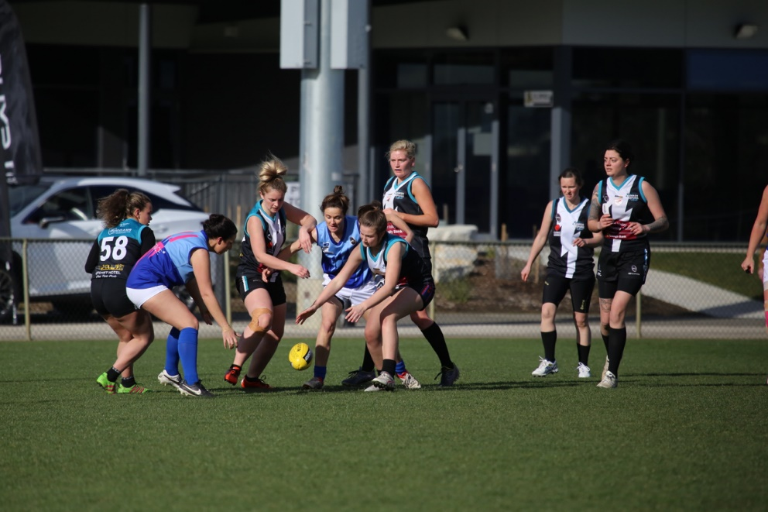
Port Captain Caitlin Phillips capped off a great season and fought hard over the entire four quarters, with sister, Telitha Bird also playing another great game along with Chantel Clark.
Lindisfarne continued to push on throughout the day, maximising their opportunities and extending their lead in every quarter. The Port were never disheartened and tried hard all day. With backline numbers low, a switch in her usual role saw Telisha Roland play a dominant defensive role and provide a strong backline kick-out over the game. Brittany Woolley, just a few games in from returning to football, again showed her amazing natural ability and will be an exciting player to watch for in the 2018 season.
Ella Brereton puts her head over the ball, as Caitlyn Phillips comes in to help out
In the end, the Blues were far too strong and ran out massive 94 point winners. The Port Women finished the season in fourth spot and will now play the third-placed Demons this week in a semi-final knockout.
Port Best & Fairest Count
Don’t forget the Club’s Best & Fairest counts will take place at the Clubrooms after this week’s finals, commencing at 7pm. There will be a count for the Colts, Reserves, Port Women and Seniors (including the Synnott Brothers Award).
GO THE PORT!!!!

