Good Day for ‘’The Port’’ at Sorell
Keep the calendar clear for the Ventriloquist Night at the Cygnet Clubrooms, check out details on the Facebook page and get a group together for a great night of laughter.
The Cygnet Football Club travelled to Sorell this week for u19, reserves and seniors and our Port Women having the Bye. On a beautiful, if breezy day the Cygnet sides returned home with two wins from three games.
Seniors
The Cygnet Football Club travelled to Sorell last Saturday and welcomed back Adam Duggan for his second game of the season. It was a very sluggish Cygnet side that saw the Sorell side dominate the play in the first quarter. Simple skill errors resulted in many turnovers for the Cygnet side but to the Eagles credit they dominated the centre clearances giving their forwards first use of the ball. The backline of the Port was under some severe pressure and were holding up well. Had it not been for the work rate of Kane Nielsen, Nathan Duggan, Jackson Gordon, Mitch Direen and Tom Slevin, the difference at quarter time would have been much worse for the Port. The only goal in this quarter went to Jake Dance for Cygnet.
Unfortunately, Cygnet’s poor form continued into the second quarter. The intensity and pressure from the Eagles resulted in a dominance of the centre clearances and the inside 50’s. As a result, the Eagles managed to pile on 4 goals in the second quarter compared to another solitary goal from the Cygnet. At half time the only thing keeping Cygnet in the game was some inaccurate kicking from Sorell. Halftime saw Sorell hold a good lead over Cygnet, with the only goal for Cygnet coming from James Zeitzen.
After Coach Ben Cato’s strong words over the halftime break it was a different Cygnet side that returned to the field for the third quarter. Ben himself led from the front as he enforced some much-needed intensity within the midfield. Cygnet were first to the ball and showed the intensity that was lacking in the first half, dominating the centre clearances and the inside 50’s. Ben Halton was unstoppable up forward with 3 goals for the quarter. The other goal kickers were Corey Polley, Joe Direen, and Braden Livingston. The immense pressure from the Port forwards resulted in 6 goals to 2 in this quarter resulting in the Port taking a slender lead.
The final quarter also belonged to The Port who once again dominated the centre clearances and the inside 50’s – with Jennings, Cowen, Cato and Livingston all contributing well. Big forward Joe Direen dominated inside the 50 with 5 goals for the quarter. Two goals went to small forward Jake Dance and another to Ben Halton. Better players for the Port were Coach Ben Cato who led from the front when he was needed the most. Kane Nielsen and Rhys Jennings were solid four quarter performers. Mitch Direen and James Zeitzen provided some much-needed run off the half backline and wing, and the two big guns up forward – Ben Halton and Joe Direen were dominant.
Cygnet 16.19.115 def Sorell 8.14.62
Goal Kickers: J. Direen 6, B. Halton 4, J. Dance 3, B. Livingston, J. Zeitzen, C. Polley
Best Players: K. Nielsen, R. Jennings, M. Direen, J. Zeitzen, B. Halton, J. Direen

Reserves
In a battle for their first win of the season between Cygnet and Sorell both teams were desperate for the ball. Cygnet had a lot of the ball but turnovers and poor delivery in the forward line saw them score points rather than goals. The first quarter saw Marcus Coulson leave the ground with a hand injury and he did not return to the field. Unfortunately, Sorell were more composed up forward and were able to take a telling lead into the first and halftime breaks, Sorell 4.1.25 leading Cygnet 1.4.10.
After half-time Cygnet again had most of the play but a breeze across the ground was playing havoc with their goal kicking. The backline repelled many Sorell advances, with ever reliable Dallas Millhouse great in defence, ably assisted by Luke Smith, Ashley Hutchinson and Tarrin Hayers. Sorell was restricted to 1.1 in the third, but Cygnet posted 1.5 which saw them down by 11 points.
The Cygnet boys threw everything at the Sorell Eagles in the final quarter and again had most of the ball in their forward line for the quarter. Unfortunately, they were only able to score 4 points to Sorell’s 3 and they went down by 10 points and are still looking for their elusive first win of the year. They will have another shot at their next game against New Norfolk in two weeks.
Sorell 5.5.35 def Cygnet 2.13.25
Goal Kickers: M. Coulson, M. Coulson
Best Players: L. Smith, D. Millhouse, A. Hutchinson, G. Brereton, T. Hayers, J. Direen

U19 Report by captain & budding journo - Will Polley
Low on Numbers, But full of Heart Victory!
The Southern Storm Colts travelled to Pembroke Park to take on the Sorell Eagles for the first time this season. Due to a string of injuries and unavailable players the Storm team had only 19 players, including 3 under 16’s taking the field.
The wet and greasy morning saw The Storm take the ground determine to show the competition the depth of the squad. This was evident right from the get-go with a hard bodyline attack on the footy which awarded Brayden Dowling with the first goal of the game after a string of well executed hand balls. The expected dog fight for the wet hot footy was evident but the first in, head over the footy mentality of the storm boys did not go unrewarded, with Luke Ashlin showing tremendous skill and composure despite the conditions, throughout the midfield to reward his key forward in Blake Sculthorpe a great first quarter goal. Brayden Dowling was found again securing his second for the game with his first to the ball mentality. Unfortunately, again the string of injuries continued with Harry Tolhurst going down with a knee injury and was to take no further part in the game.
After being asked to dig deep and step up at quarter time, taking the field with only 18 players, the Storm boys really gelled together and it became the quarter of new comers to the team with Sam Ryan and Josh Memory showing what they have to offer with a series of marks and second efforts to aid the team efforts. The team was led from the front again by Captain Josh Coad who provided excellent run and direction. Reece Scotland provided leg speed and carry up the ground to help with forward entry despite only two majors for the quarter which were rewarded to young Jonte Fahey (4 goals for the game) and Brayden Dowling.
The third term showed how determined the team was to impact the score board and really run away with the game. This was showed through the likes of Murray Bastick who continues to show why he is called ‘The Bull’, with his helmet seen exploding through tackles and holding onto the football like he was a magnet. This was contagious for the rest of the Storm team, as you could find Liam Slater, showing that he could dance around players, provide pinpoint handballs and provide continual second efforts to aid in the team’s 5 goal quarter. Goals went to Bruk Duggan with another great snap, Jonte Fahey with 2, Ryan Clark 1 and Reece Scotland.
The final term showed how far the engines of the boys could go with the whole team giving their all in the third, the boys continued to fight. Keeping the Eagles to just the one major and two minor scores for the game. The comradery of the boys aided in what was really an all-round team effort to bring the Colts home with the win.
In again, an extremely well-played team game, better players included Luke Ashlin, Reece Scotland, Josh Coad, Murray Bastick, Liam Slater, and Blake Sculthorpe. We wish Harry Tolhurst all the best with his injury and hope he is back on the field soon.
Southern Storm 12.6.78 def Sorell 1.2.8
Goal Kickers: J. Fahey 4, B. Dowling 3, R. Clark 2, R. Scotland, B. Sculthorpe, B. Duggan
Best Players: L. Ashlin, R. Scotland, J. Coad, M. Bastick, L. Slater, B. Sculthorpe

Next Games
This week is the Queen’s Birthday weekend so a chance for a bit of down-time for the players, committee, trainers, volunteers and everybody who helps & assists the Port – BUT – next weekend on 15 June footy returns to Snug Park when we will host the New Norfolk Football Club with 4 great games of football on one of my all-time favourite grounds to play on!
The Port Ladies will do battle with the very strong Kingborough team at 10.00am. We are lucky to have a great association with the Kingborough Tigers who often lend players and it should be a game firmly contested, but played in great-spirit! We wish both teams the best of luck but hope The Port ladies can put on a great show – good luck girls!
‘’Big Bazza’’ Hall Day
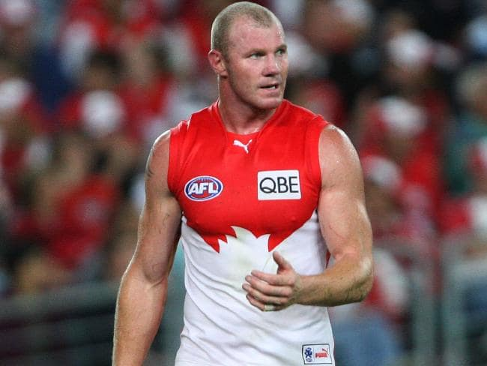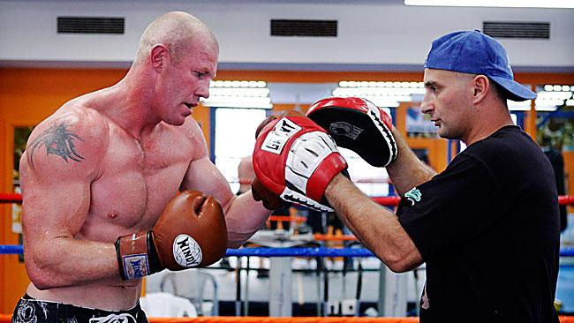
The planning for a massive day when Barry Hall will play with The Port against Lindisfarne Football Club at Cygnet Oval on 27 July is well underway by the committee and a range of other helpers busily working behind the scenes. Followed by a sportsman’s night, this promises to attract one of the biggest crowd’s ever witnessed at Cygnet Oval for some time. Whatever you do, do not miss the game or tickets to the sportsman’s night plus a variety of raffles for Cygnet and AFL jumpers signed by the big hard-man himself. It’s going to be BazzaTastic!!!
Major Sponsors
Top Hotel
Cygnet Community Banks

Associate Sponsors
Southern Smash Repairs, Cygnet Water
Cartage, Abel Labels, Festival IGA Everyday,
Southport Hotel & Caravan Park, Cygnet Building
and Joinery, Duggans P/L, The Huon News,
Commercial hotel, Oakford Plumbing, Tom Moore
& Son, Elite Painters, Scott Thiessen

Weekly Award Donors
Cribbins BP, Commercial hotel, Roy’s Bitz of Old
Pizza, R & D Meats, The Top Pub, Wilcox Electrical,
Jacky’s Café, Brereton electrical, Port Huon
Trading Post
Please support those who support us !!

“Support the Port in 2019’’

